

Administrator How-to

OC Performance Scheduling

Oklahoma Christian University

Table of Contents

Process Overview 2

1. Event Flow 2

a. Prior to the Event Day 2

b. Event Day 2

2. Recital PDF Report 3

3. Beginning of a Semester 3

4. End of a Semester 4

Functionalities 5

1. Login Steps 5

a. Login 5

b. First Time User or in the Semester 8

2. Home Page 9

3. Performances Page 11

a. Explanation of the Page 11

b. View Instructors’ Critiques/Grades/Ending Levels 13

4. Maintain 15

a. Users 15

b. Events 21

c. Event Types 23

d. Instruments 27

e. Composers 30

f. Pieces 33

g. Majors 38

h. Levels 40

i. Semesters 42

j. Locations 43

5. Logout 46

# Process Overview

## Event Flow

### Prior to the Event Day

* An event needs to be set up. Go to **Maintain** and then **Events**.
* Click on “**Add Event**”.
* Fill out all the proper information and click “**Save**”.
* If you would like to notify instructors and accompanists, go to **Home Page** and find the event.
* Click on “**Notify**” to send an email to all of them alerting a new event was created and they need to enter their availabilities.
* Click on “**View Signups**” to view who has already entered their availabilities.
* Once all instructors and accompanists have entered their times, click on “**Ready**” to make the event visible for students.
* Click on “**Notify**” to send an email to all active students, instructors, and accompanists alerting them that the event is available for them to sign up.
* Click on “**Reminder**” if you would like to send an email reminder to all students, instructors, and accompanists that are signed up for the event.

### Event Day

* In order to get the event program to put on the event’s room door, go to **Home Page**.
* Find the event and click on “**Event Report**”. This will download the program with all students signed up for the event, their time slot, instrument, private instructor, accompanist, and pieces performing.

## Recital PDF Report

* After a Recital Hearing is completed, a Recital PDF Program is generated with the students that passed.
* To download it, go to **Maintain** and then **Events**.
* Find the event and click “**PDF Program**”. This will download a program with all students that passed, their information and their pieces performed information.

## Beginning of a Semester

* A new semester needs to be set up. Go to **Maintain** and then **Semesters**.
* Click on “**Add Semester**”.
* Fill out the proper information, keep the “Disabled all Students” checkbox selected, and click “**Save**”. This action will disable all students in the system. They will be reactivated when they log in, ensuring that only students performing in the current semester are active in the system.
* Make sure the correct accompanists and faculty members are active on the system. Go to **Maintain** and then **Users**.
* To simplify the process, you can filter the currently active accompanists and instructors. Click on “**Filter Users**,” then click on “**Status**” and select “**Active**.” Next, click on “**Role**” and select both roles mentioned previously. Press “**Apply Filters**” to get a list of all active accompanists and instructors in the system. Make sure to disable those not working in the current semester.

## End of a Semester

* All students must have an ending level assigned by their instructors after a jury performance at the end of the semester.
* To ensure all students have their ending level, go to **Maintain** and then **Users**.
* To simplify the process, you can filter the currently active students. Click on “**Filter Users**,” then click on “**Status**” and select “**Active**.” Next, click on “**Role**” and select “Student”. Press “**Apply Filters**” to get a list of all active students in the system.
* Pick one student and click “**Edit**”. Their ending level should appear on their instrument card on the right side of the pop up.
* If you do not see it, click on “**Edit**” on the bottom right of the instrument card and check if the “Ending Level” field is filled out.

# Functionalities

## Login Steps

### a. Login

* Navigate to the [Performance Scheduling website](https://performance.oc.edu/) (click on this link that goes to <https://performance.oc.edu/>).
* We use Google to authenticate our logging in.
* You must use your OC affiliated email address to login.
  1. Click Sign up with Google.

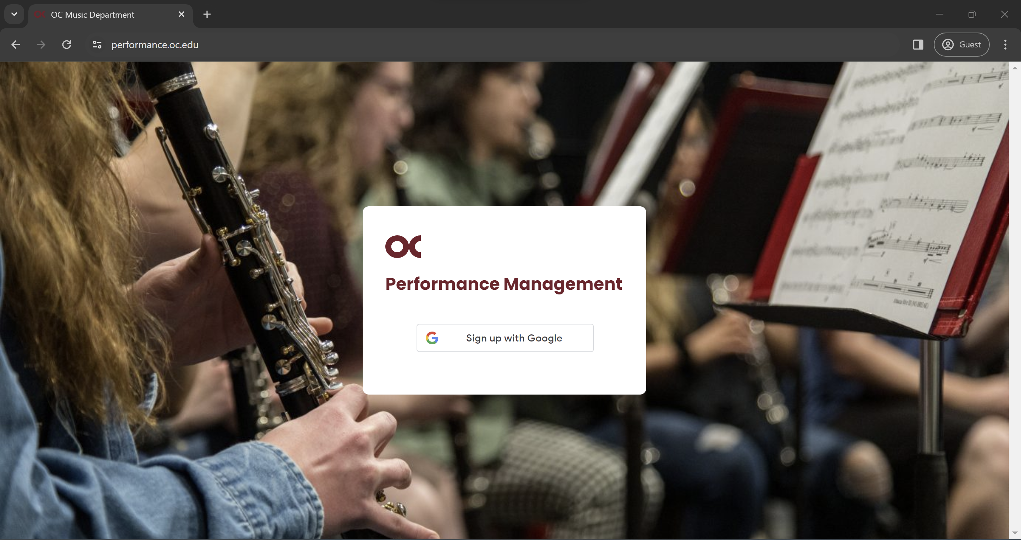

* 1. Enter your **OC** email.

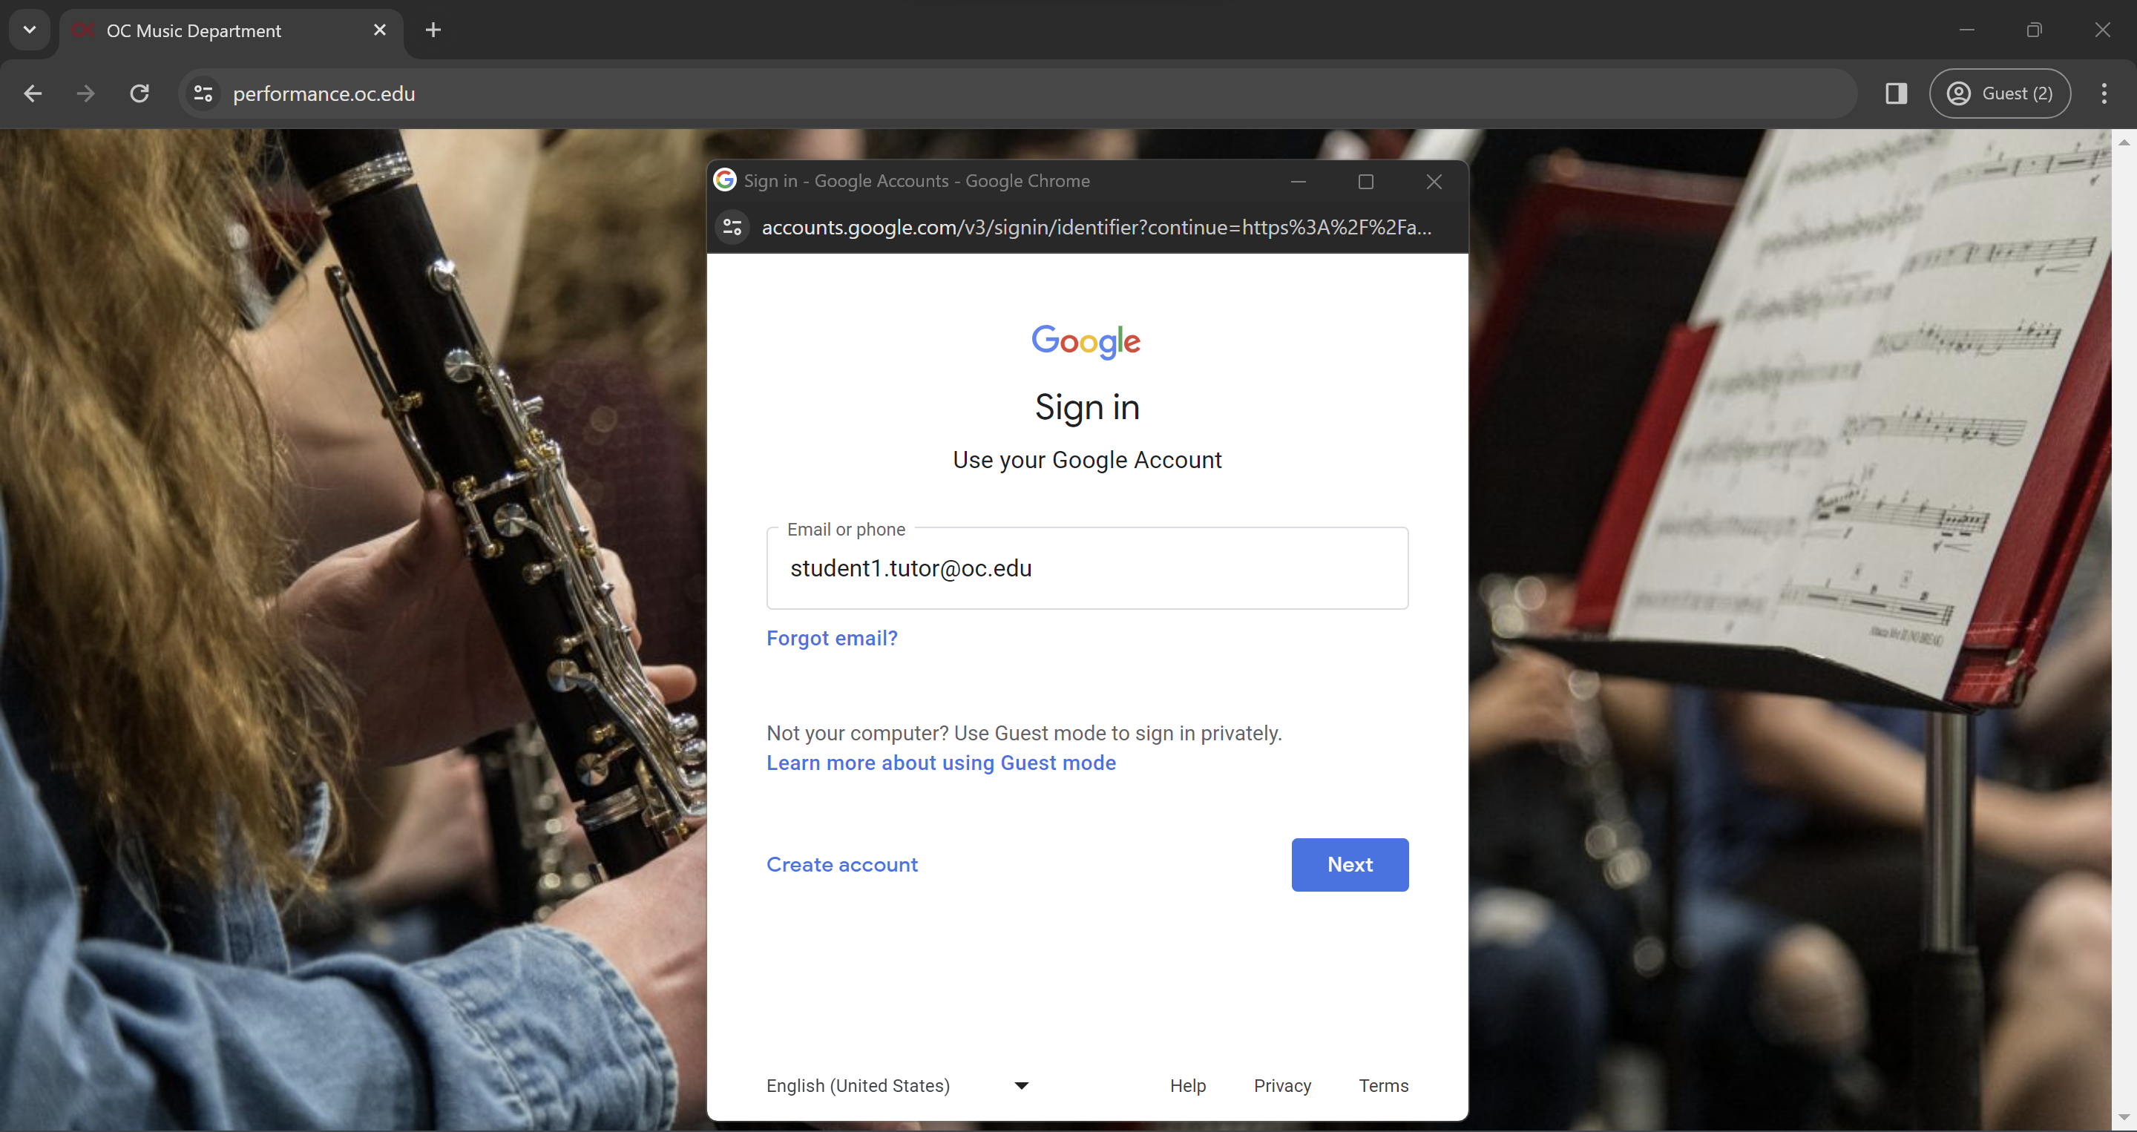

* 1. Enter your **OC** credentials.

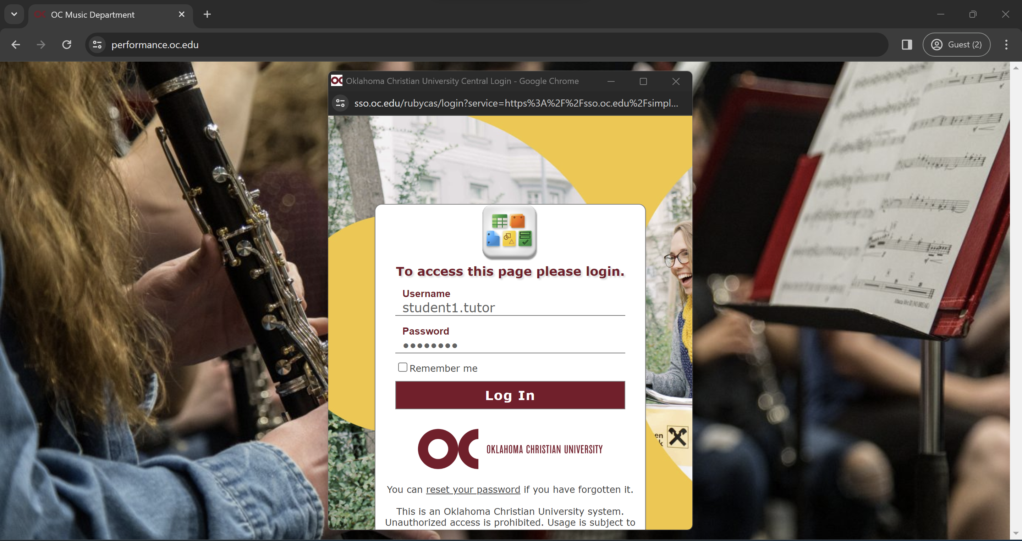

* 1. Click on the account you logged in with.

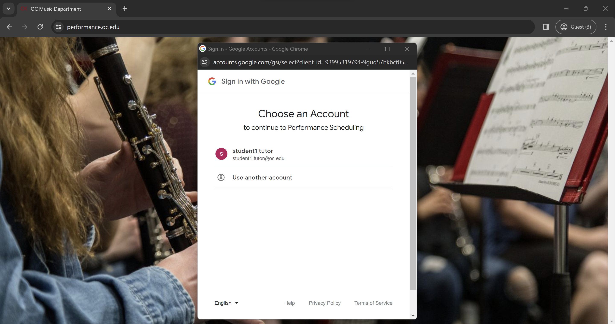

* 1. Google may ask you to give permission to share information with this site. If it does, please give the permission.

### b. First Time User or in the Semester

* When you log in for the first time, you must update your profile information.
* If you are logging in for the first time on the semester, make sure your information is updated.
  1. Click on Admin and then User Settings.

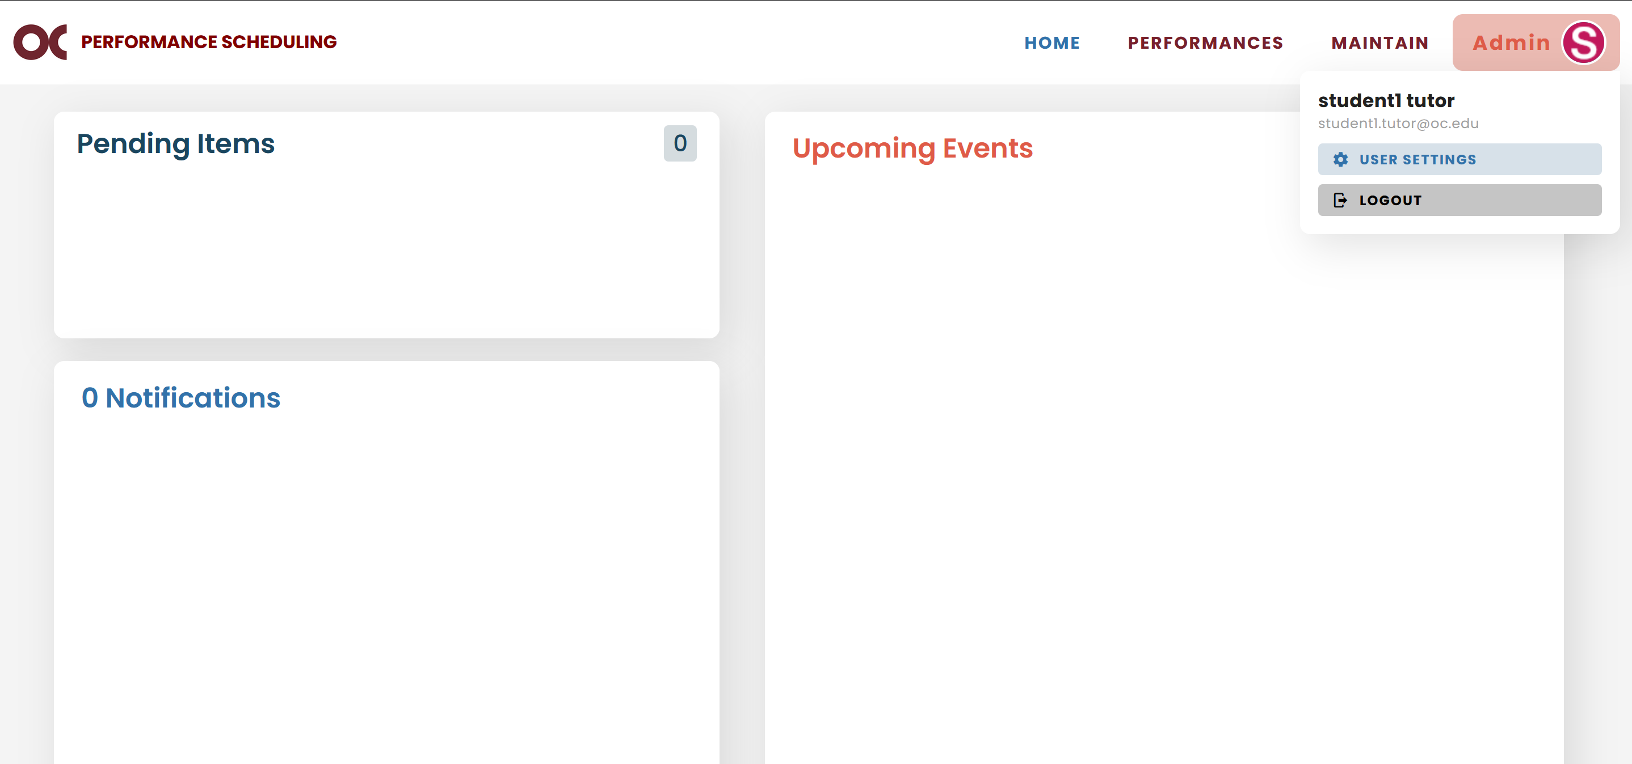

* 1. Update your profile information and click Save.

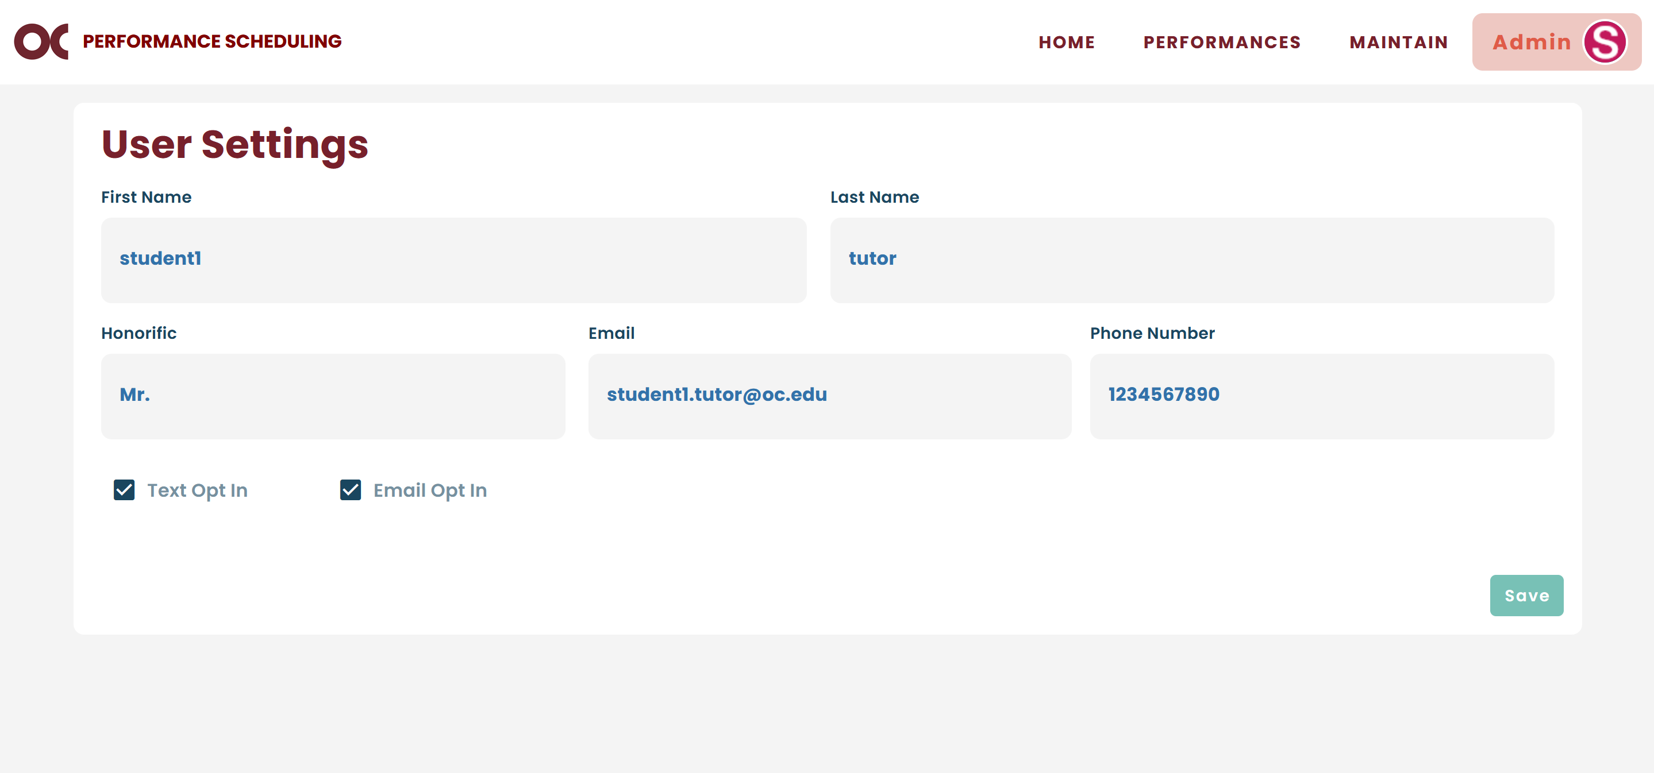

## Home Page

* Home Page is divided into three sections.
* The Pending Items section will display notifications about pieces or composers added by students that are pending the administrator’s approval.
* The Notifications section will display notifications from requests that students have made for instructors to adjust their availabilities. It will display the requester’s name and the event information. You will also receive an email about it.
* The Upcoming Events column will display all the events that will happen in the future.

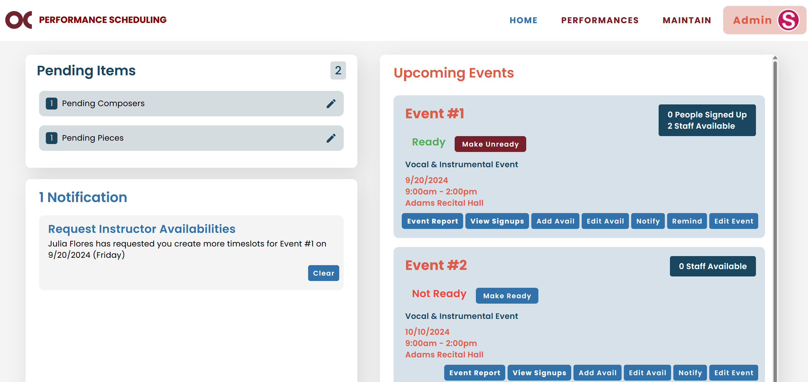

* The “Make Ready” button will make the event available for students. An event should be ready once all faculty and accompanist members have already entered their availabilities.
* The “Event Report” button will generate a pre-event PDF with the sign ups information.
* The “View Signups” button will display all faculty, accompanists and students signed up for the event.
* The “Add Avail” button gives the administrator the ability to add faculty and accompanists’ availability to the event.
* The “Edit Avail” button gives the administrator the ability to edit the faculty and accompanists’ availability.
* The “Notify” button will send a notification to all people signed up for the event. If the event is not ready, it will send a notification to all faculty and accompanists that have entered their availabilities to the event. If the event is ready, it will send a notification to all students, faculty and accompanists that have signed up for the event.
* The “Remind” button sends an email reminder to all people signed up for the event.
* The “Edit Event” button allows you to edit the event’s information.

## Performances Page

### a. Explanation of the Page

* This is the page where you can check all previous students’ performances.



* You can search by a student’s name or filter by semester and/or instructor.

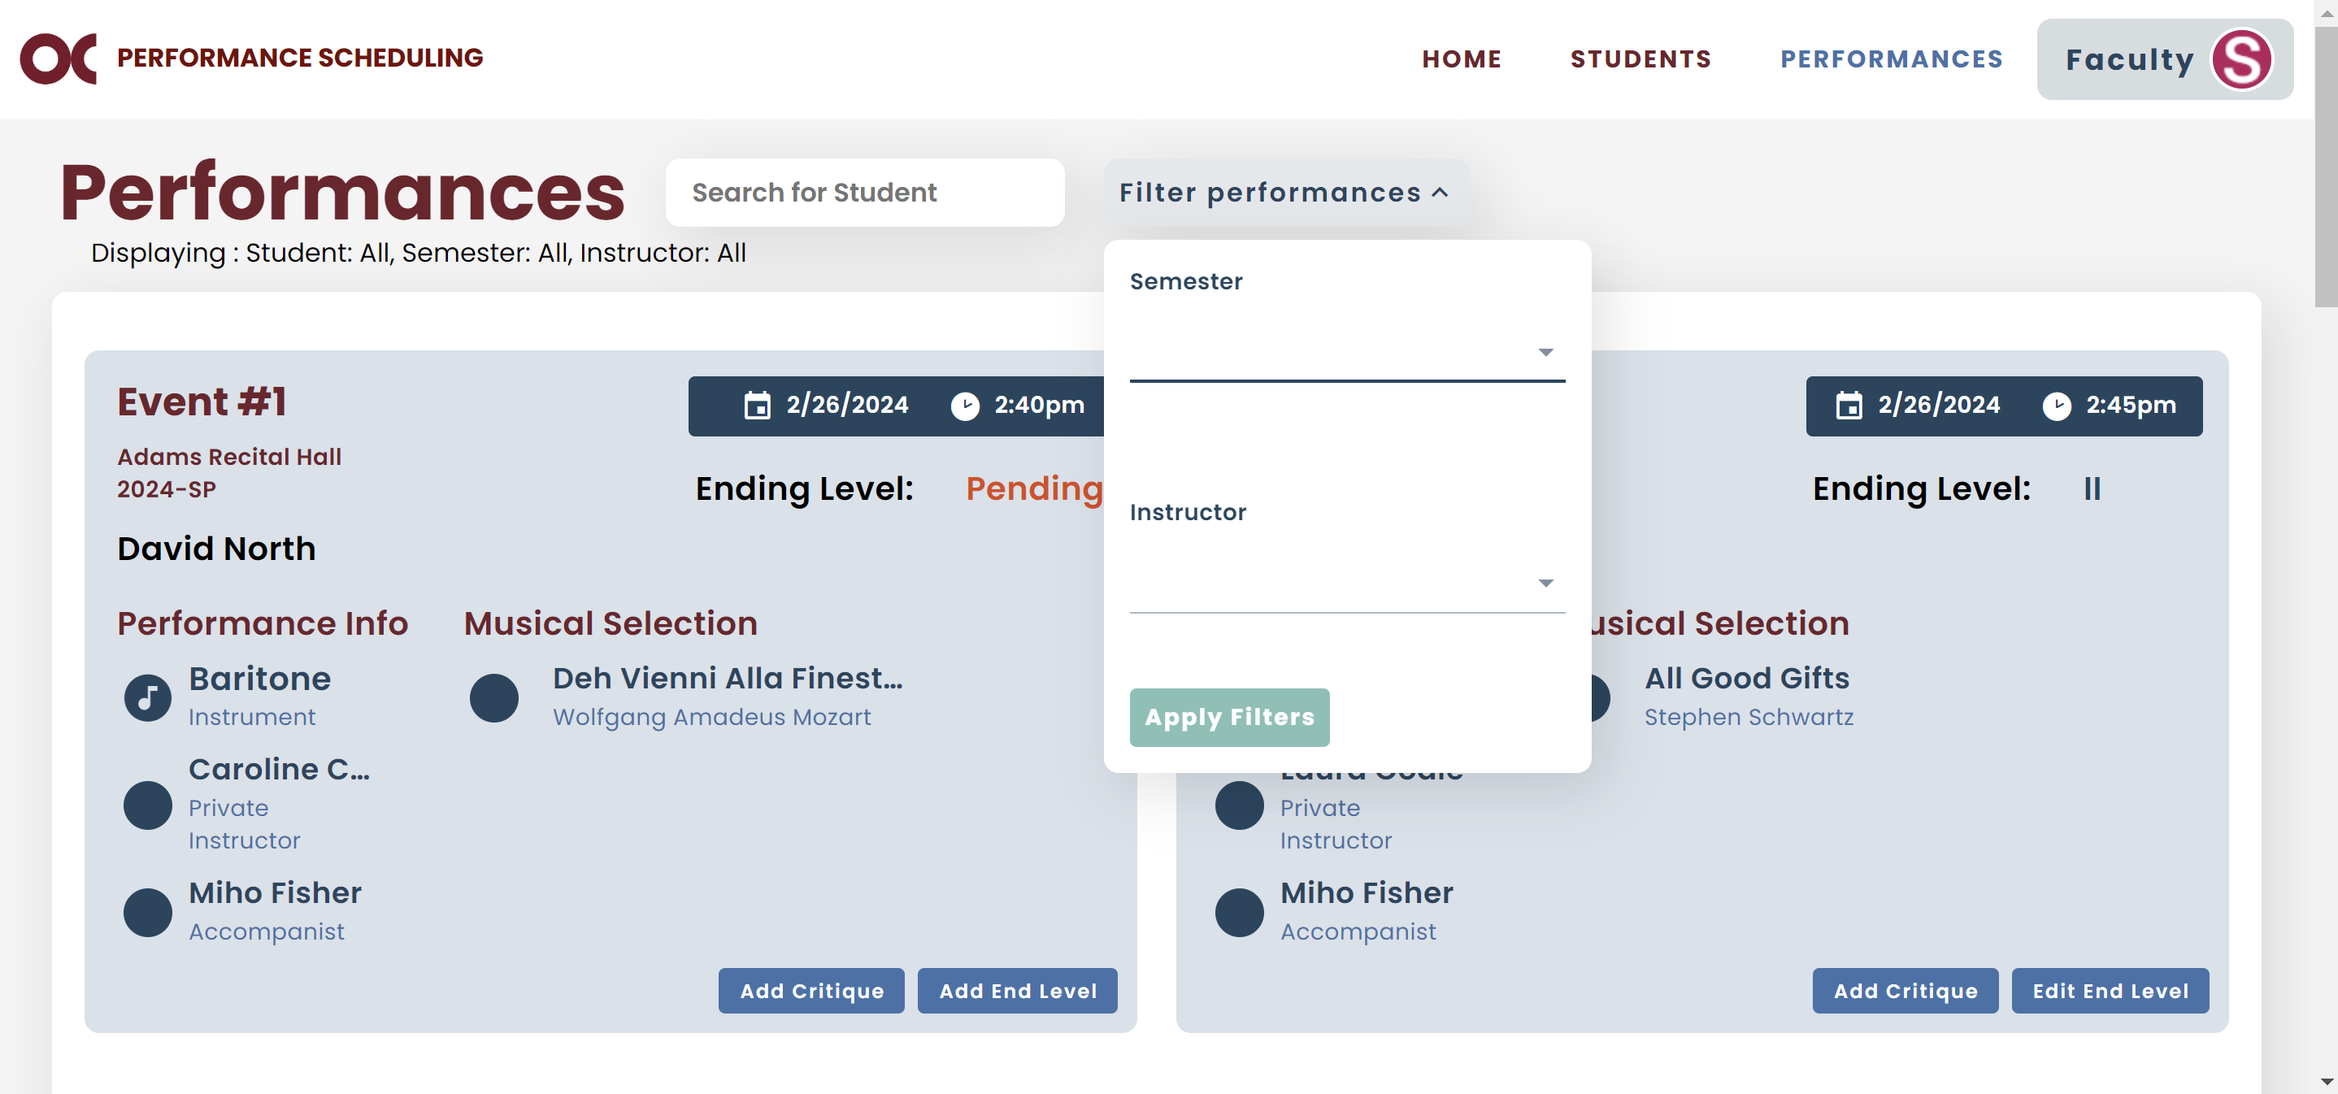

* If after clicking “Apply Filters” you do not want to use the selected filter anymore, you can click on “Clear Filters”.

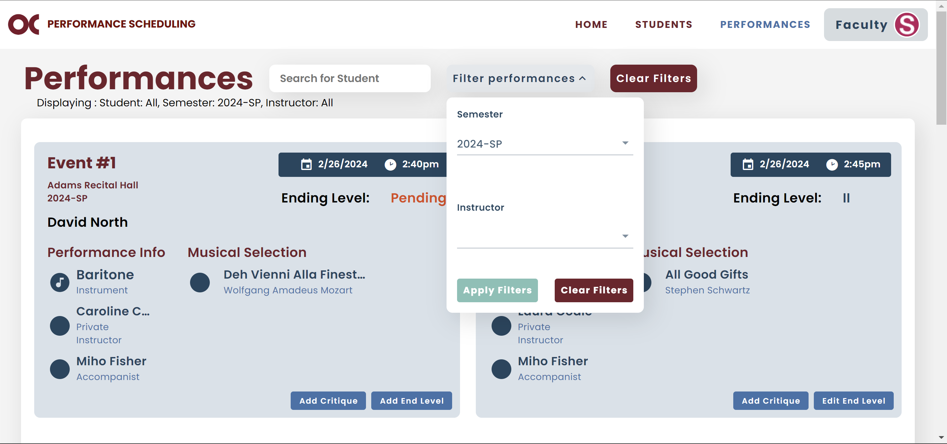

### b. View Instructors’ Critiques/Grades/Ending Levels

* You can view the instructors’ critiques, grades, or ending levels assigned to students’ performances.
* To view a student’s critiques, find the desired performance and click on “Critiques”.

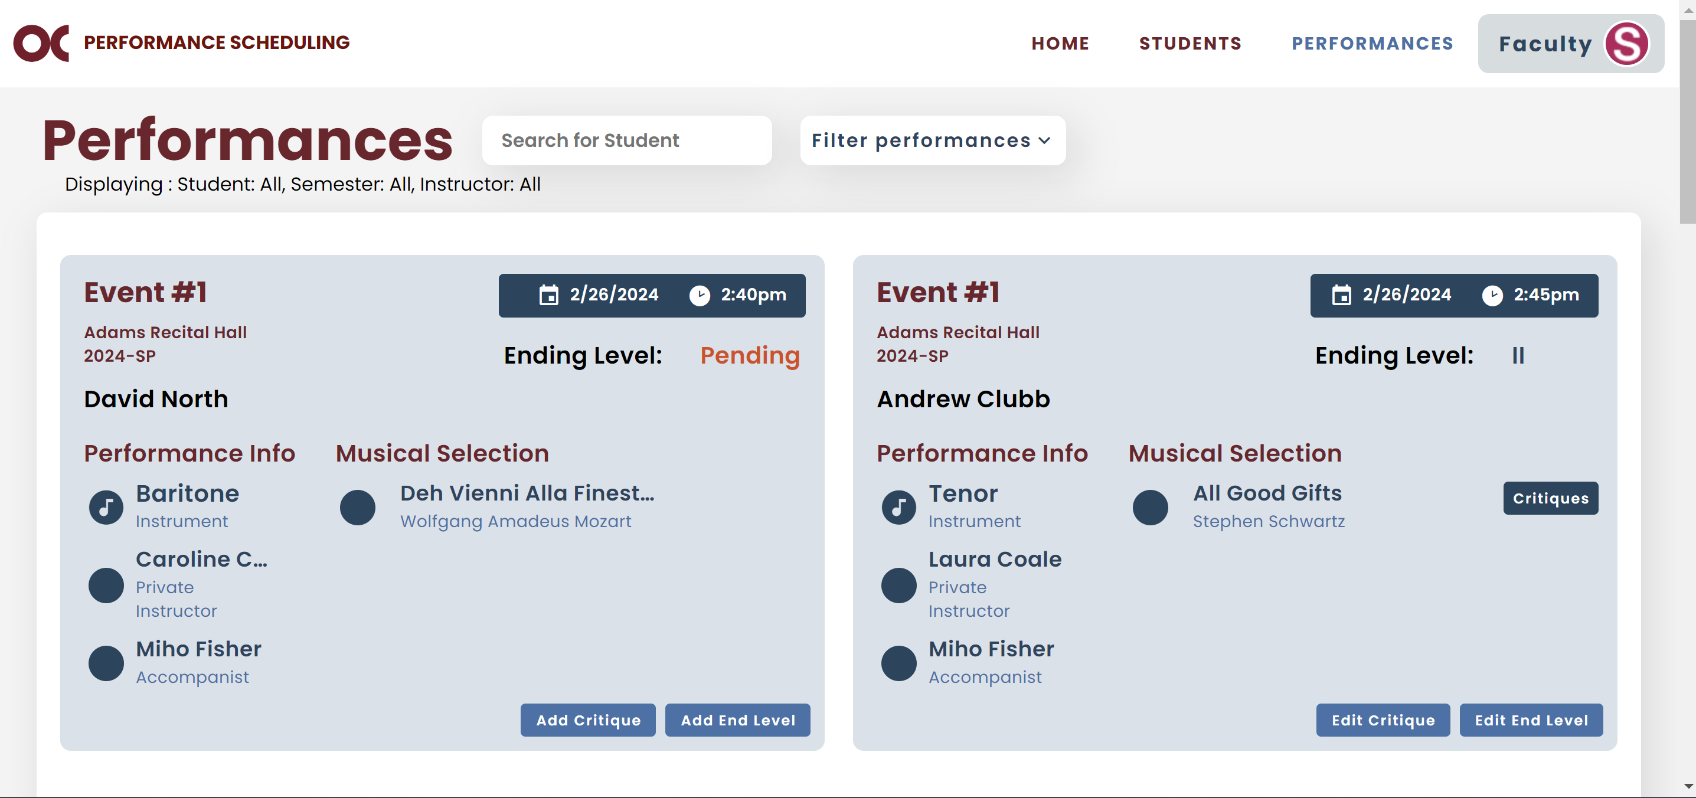

* The following screen will be displayed with all instructors’ names that have entered critiques for that performance.

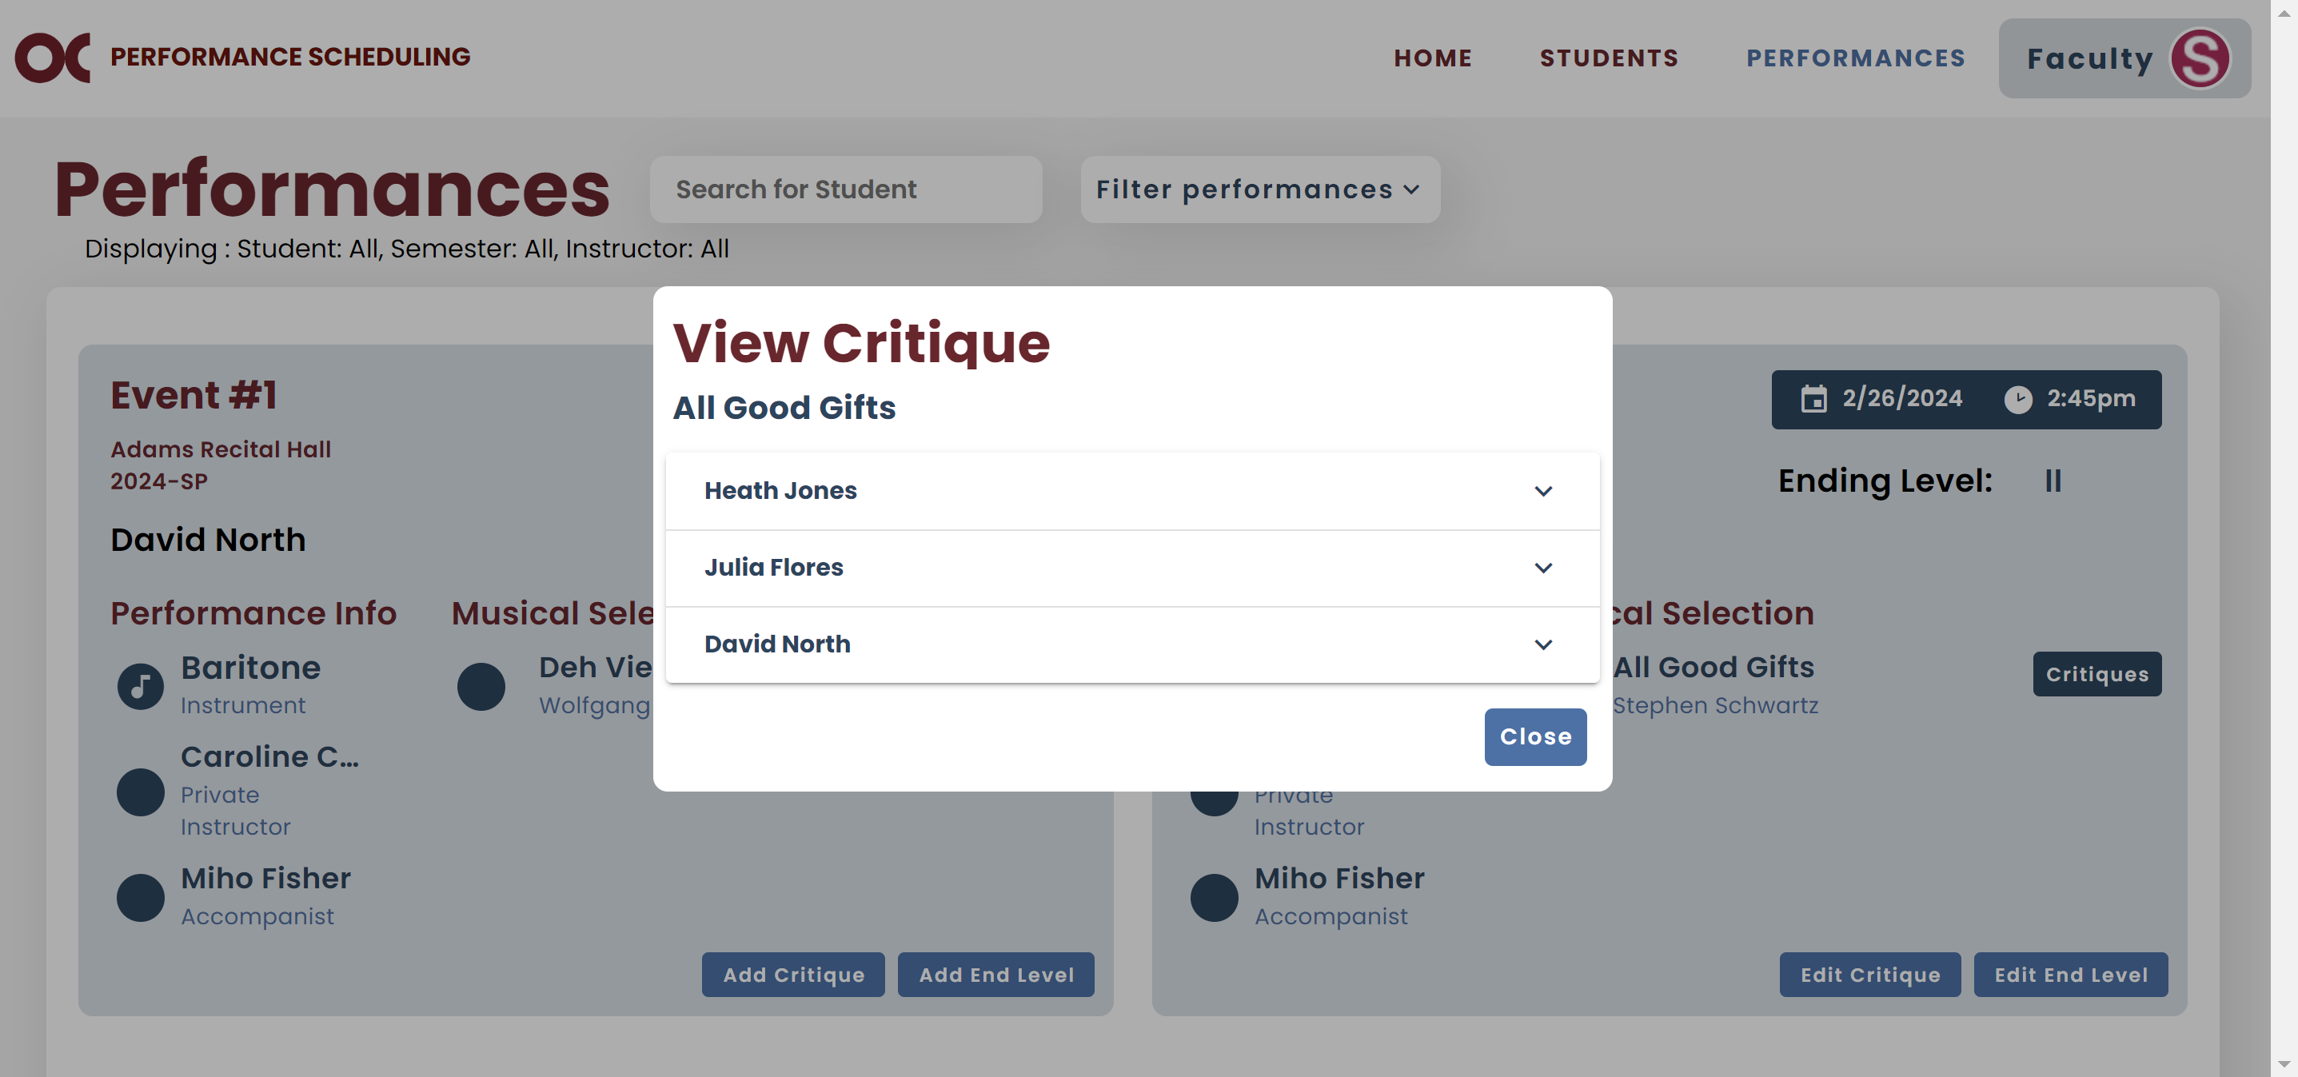

* Select the name of the instructor you want to view the critiques.

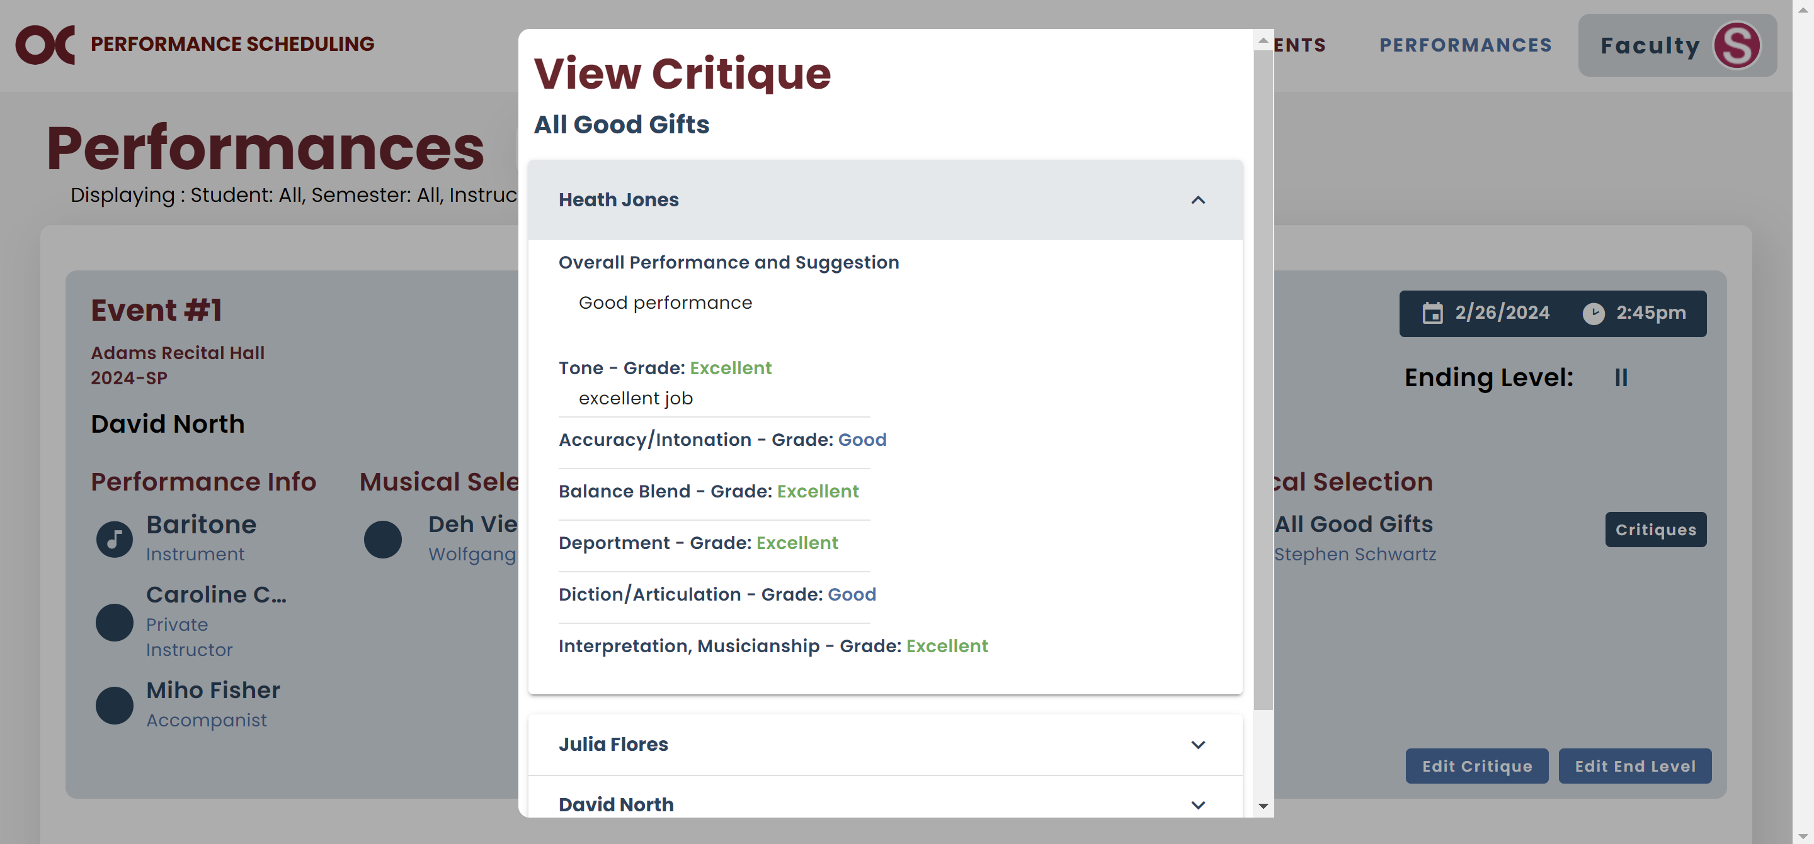

* If you want to exit the screen, just click on “Close”.



## Maintain

### a. Users

* You can view all system users on your Maintain Users screen.

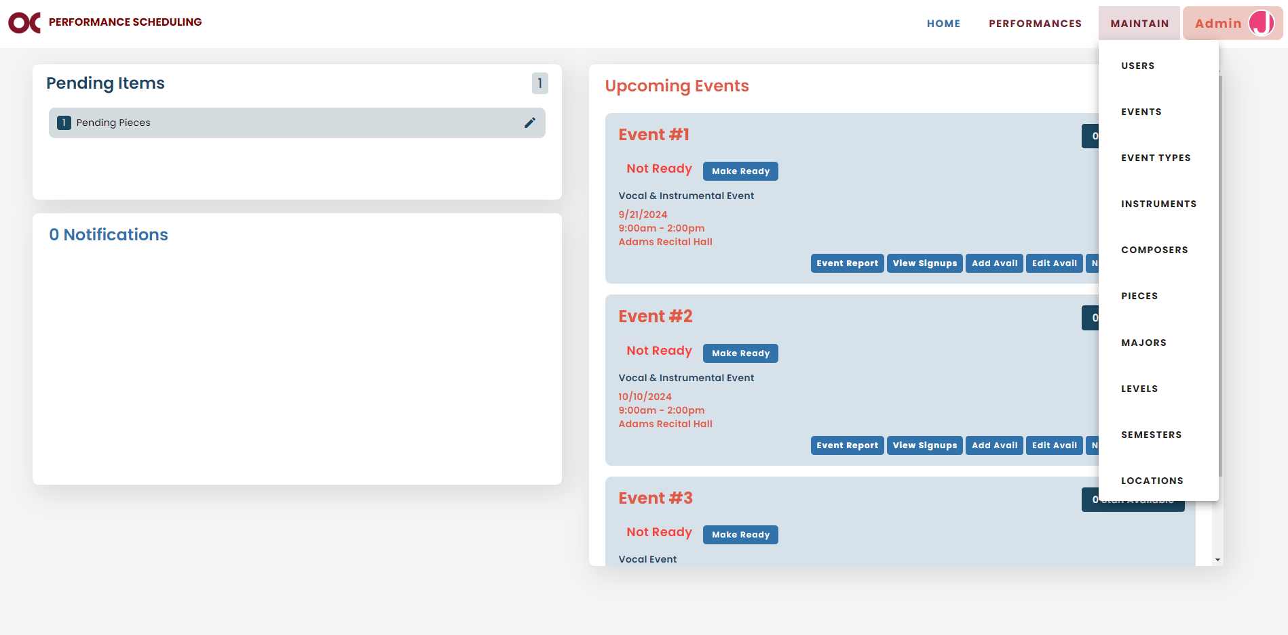

* You can filter them by their status, role, their private instructor or student type.

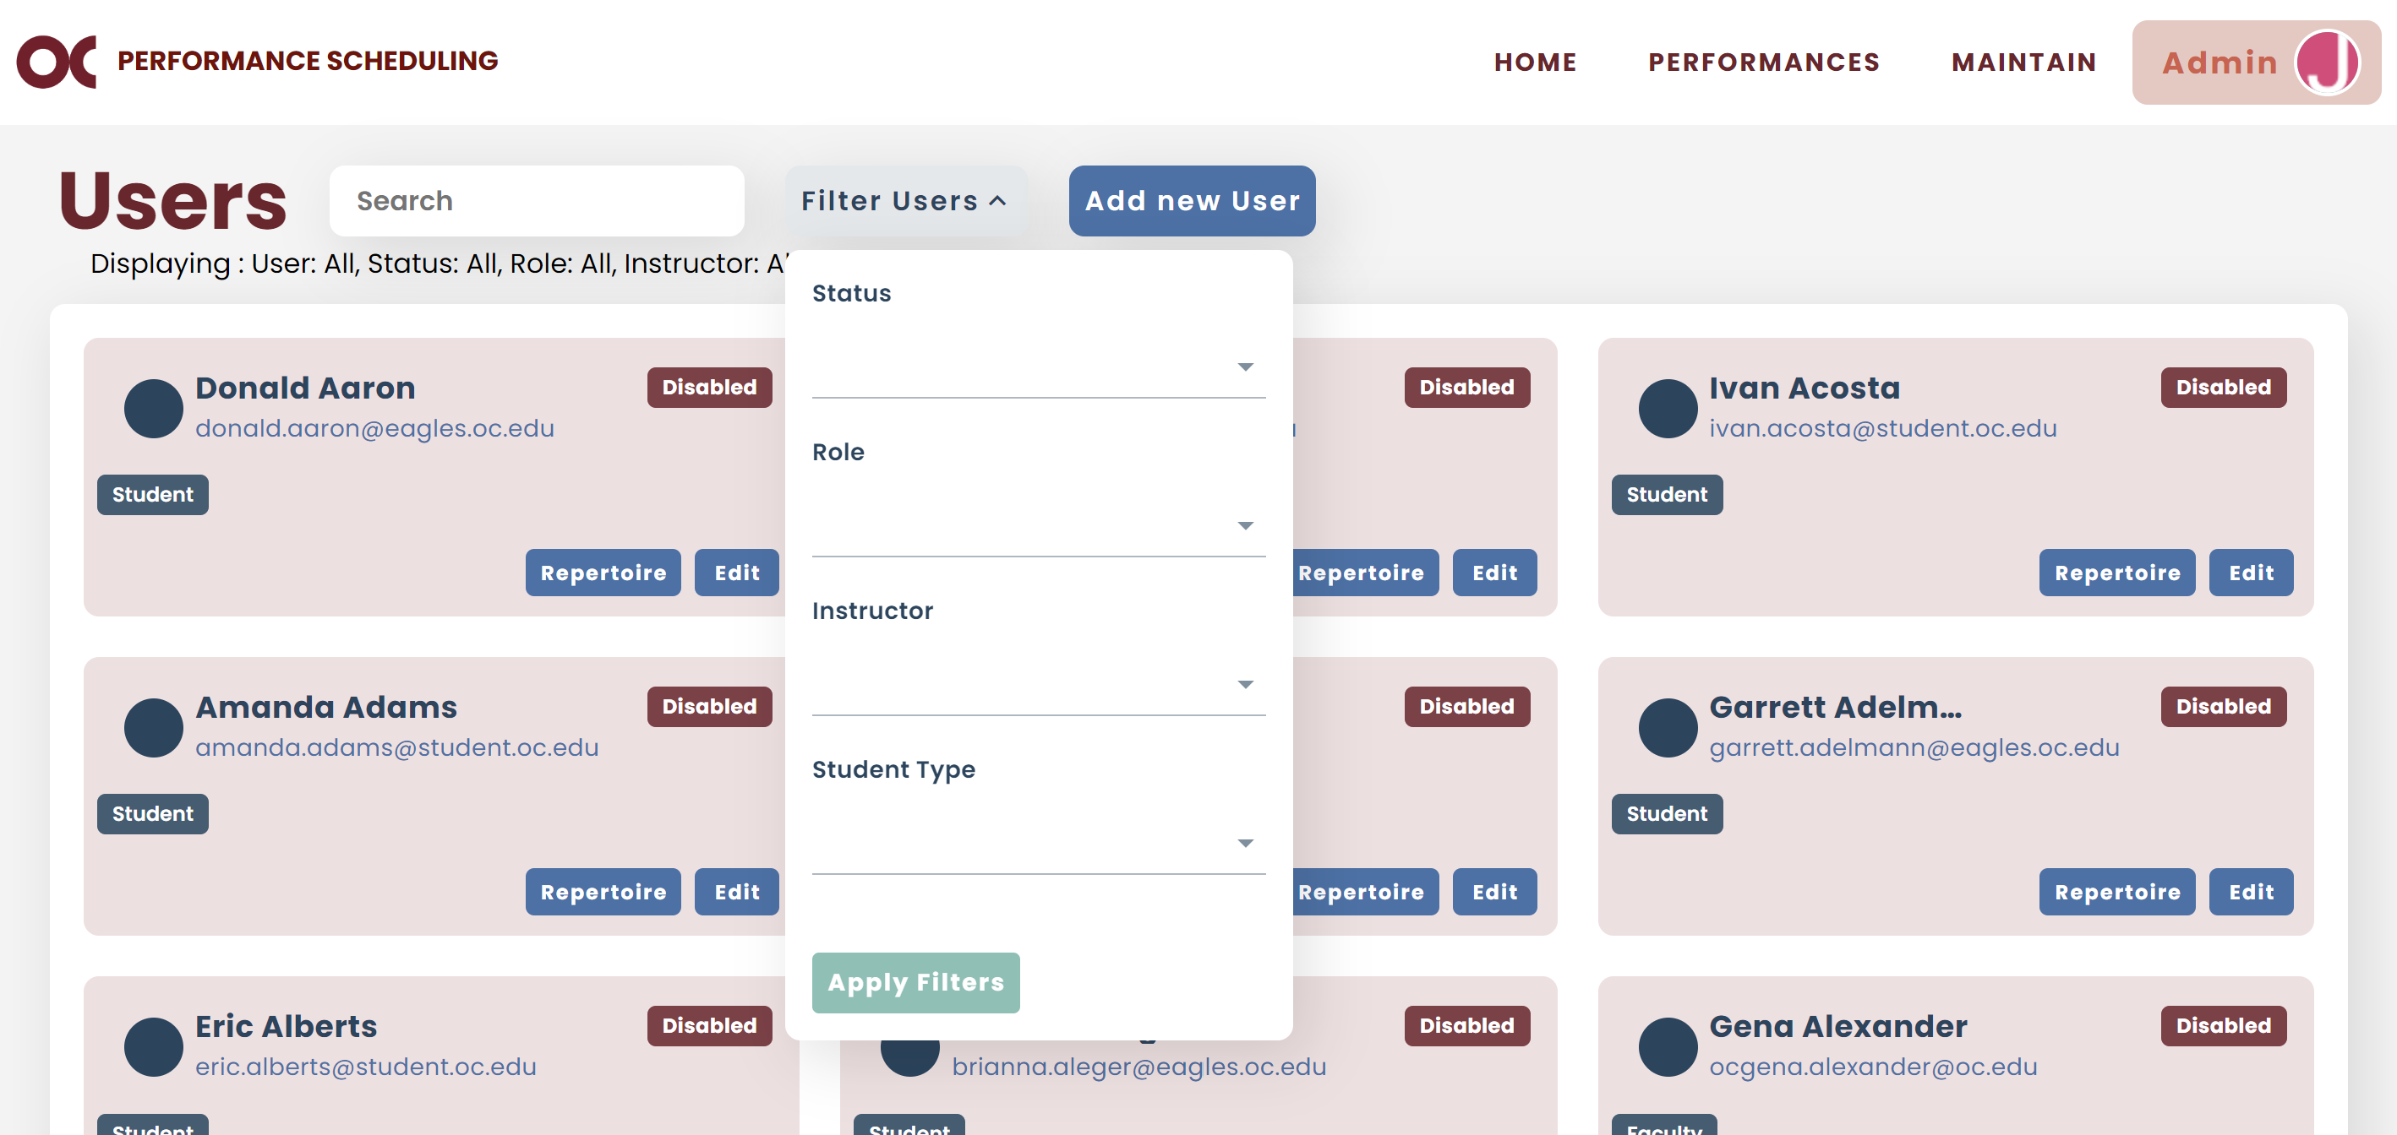

* The text below the title and search bar indicates what the current filter being applied is.
* If you want to add a new user, click on “Add new User”.

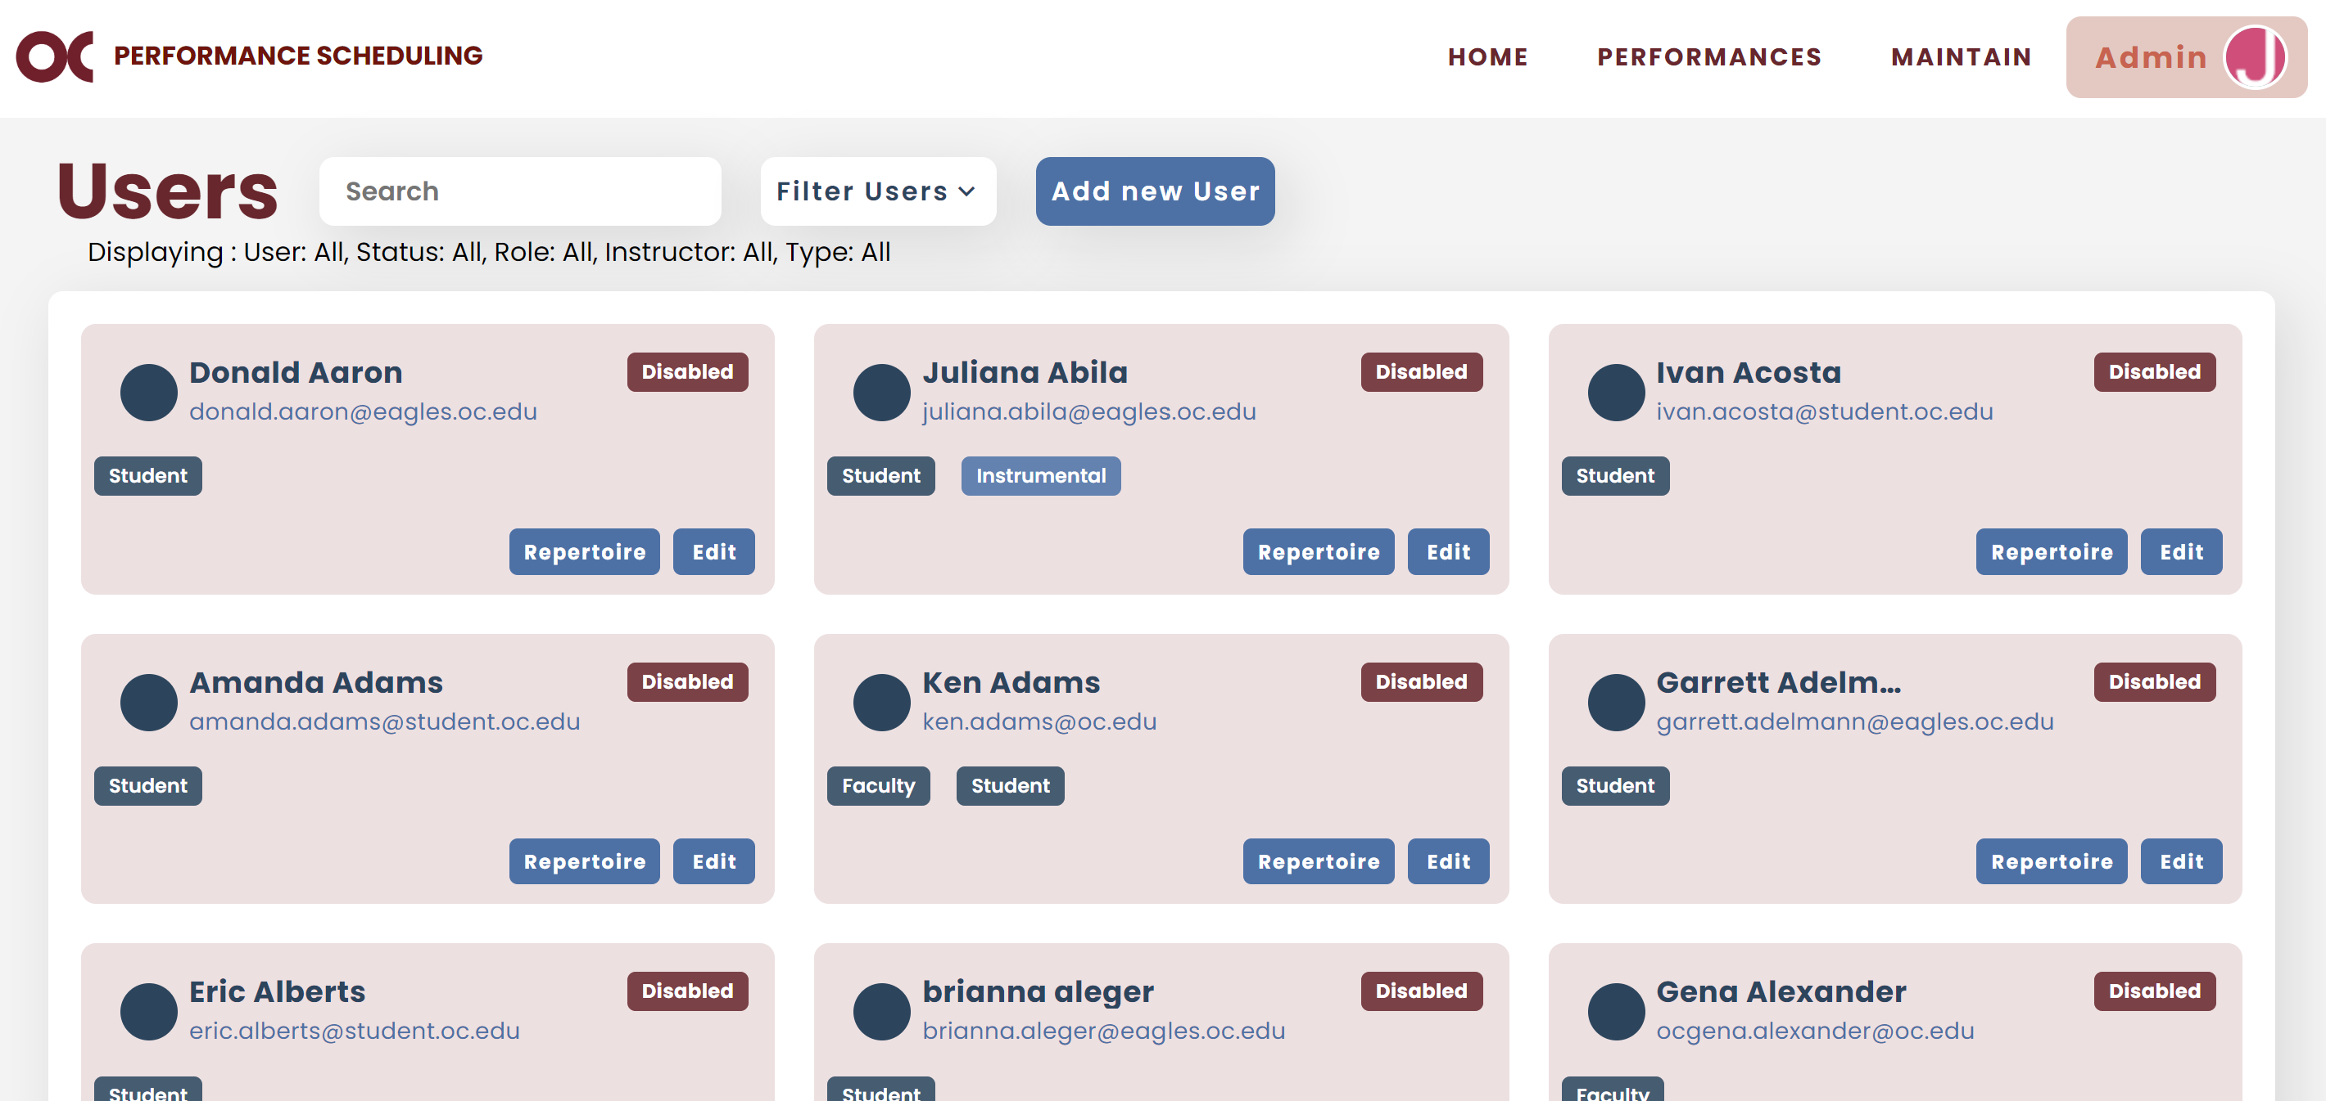

* 1. To add a new user, fill out all the fields depending on the user’s role.
  2. The “Text Opt In” and “Email Opt In” checkboxes are to enable the user to receive notifications over text or email.
  3. The “Admin Email Opt In” is to enable the user to receive all admin notifications over email.
  4. Once all the information is completed, click “Add”.

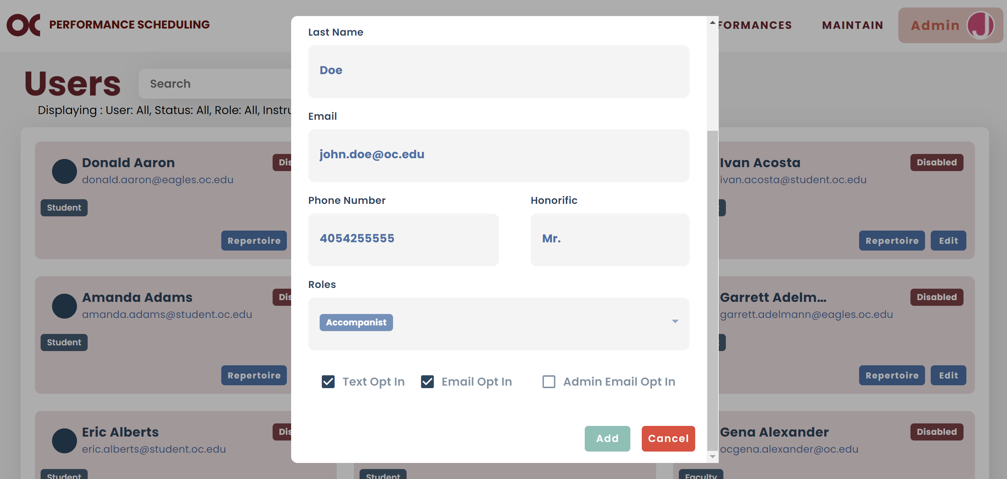

* If you want to edit user information, click on “Edit”.

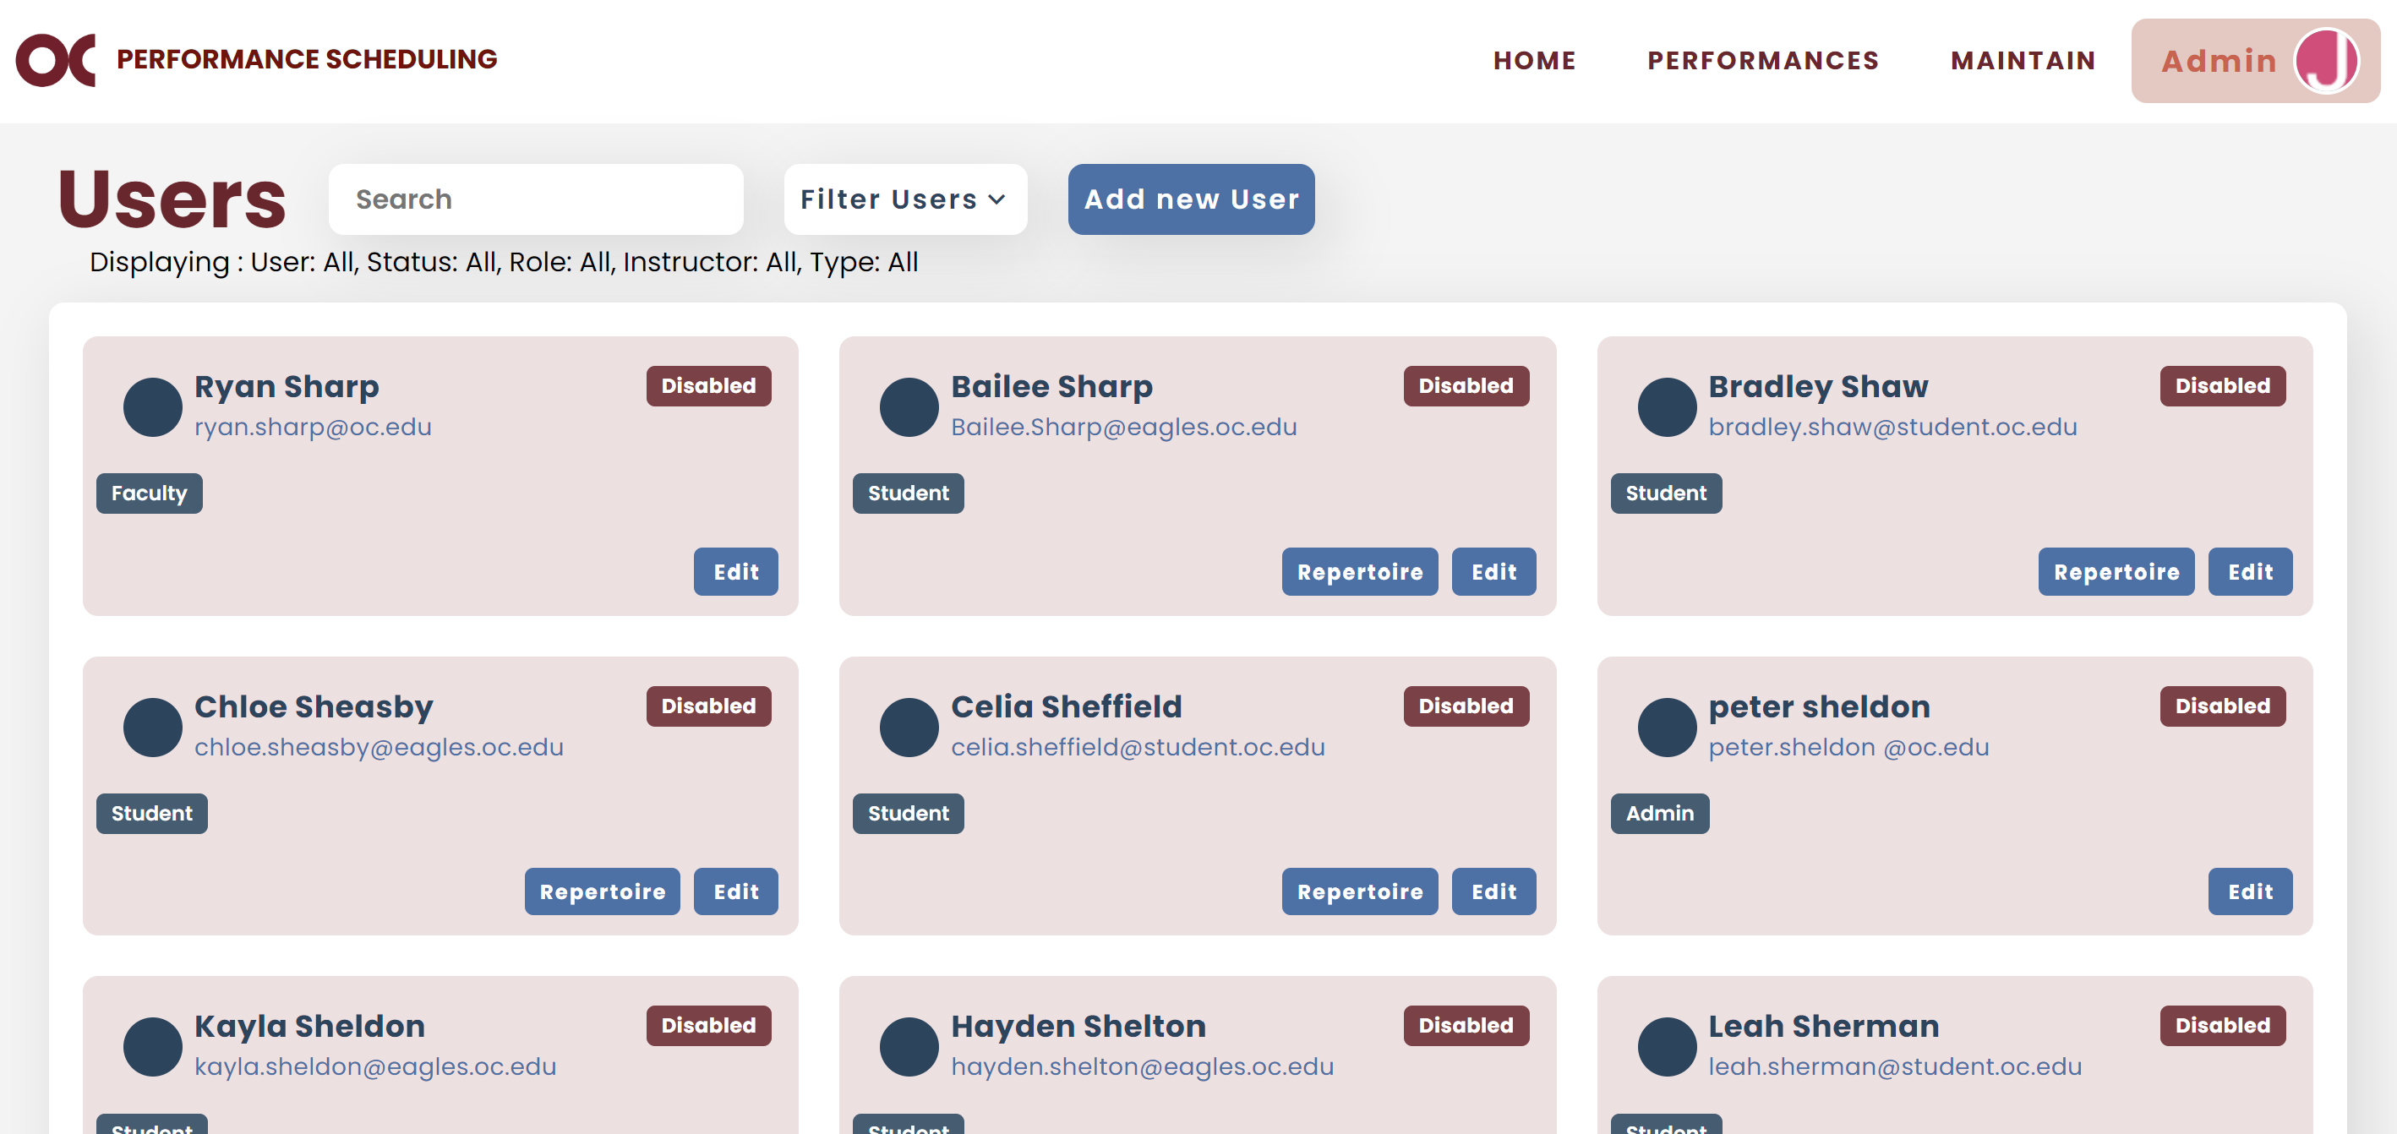

* 1. If you wish to edit the user’s first name, last name or email address, select “Allow Full Edit”.

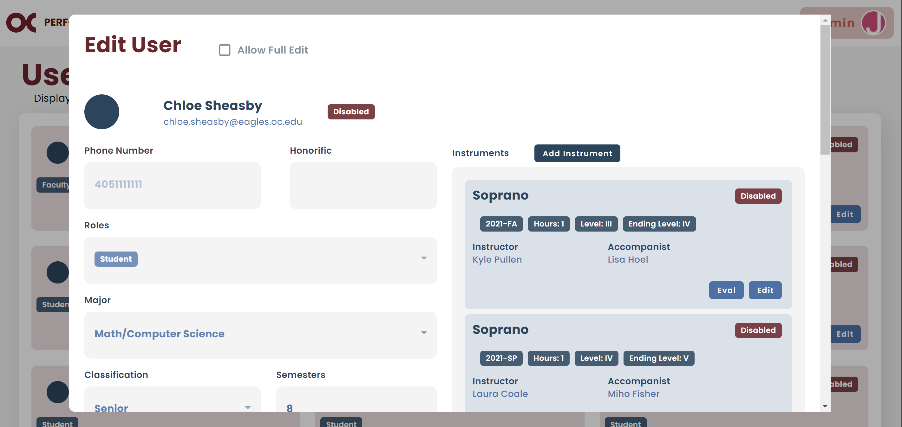

* If the user is a student, there are several functionalities that can be applied.
  1. Find the student and click “Edit”.
  2. The section on the right indicates all instruments that a student has played at OC. Each card corresponds to an instrument, and it indicates the semester it was played, how many private hours, the starting level, and ending level applied. It also indicates who was the private instructor and the accompanist (if applicable).
  3. You can add an instrument for a student by clicking on “Add Instrument”.



* 1. You can edit a student’s instrument by clicking on “Edit”.



* 1. You can check the student’s beginning, mid-term and final evaluation by finding the desired instrument and clicking on “Eval”.



* 1. You can click on the different tabs to view or edit the different terms evaluations.

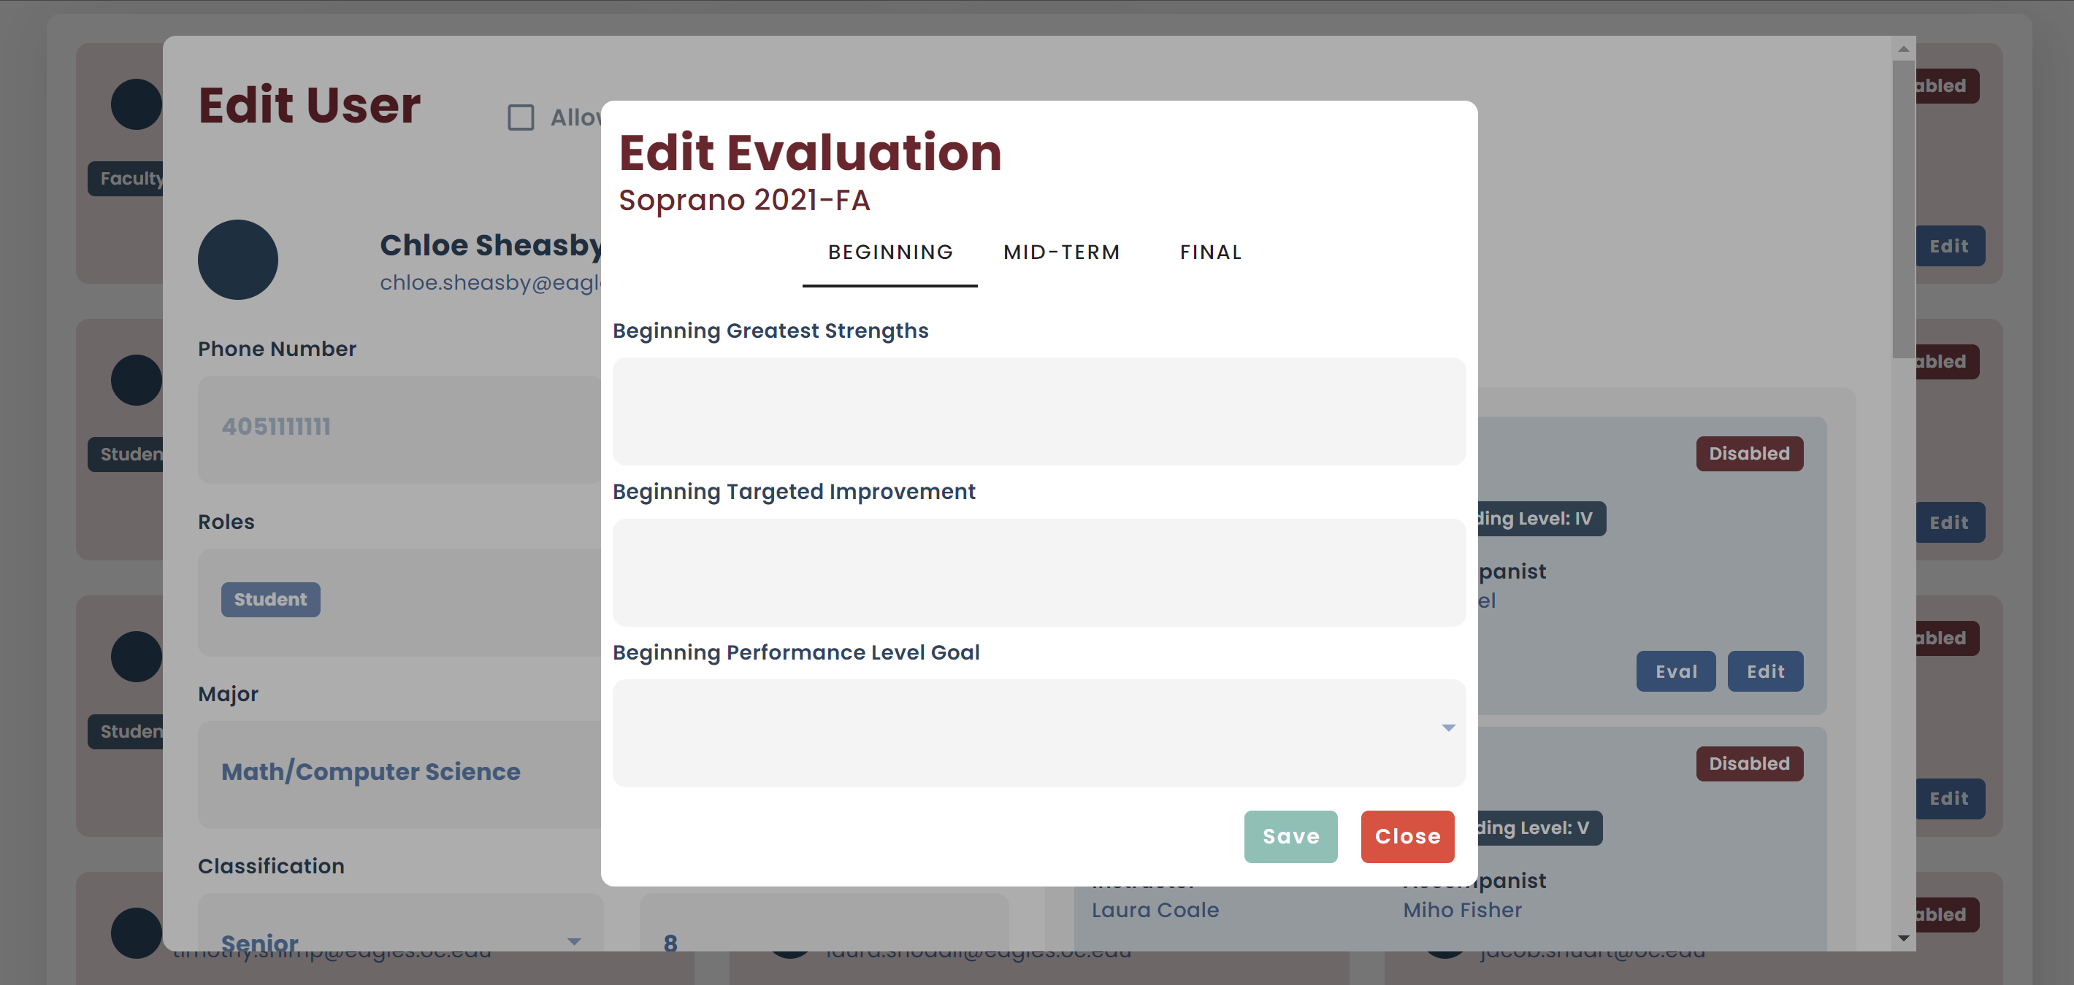

* 1. If you want to check a student’s repertoire, you can find them and click on “Repertoire”.



* 1. You will view all their repertoire pieces and their respective semester and instrument played.
  2. You also have the ability to add a new piece to a student’s repertoire by clicking on “Add new Piece”.

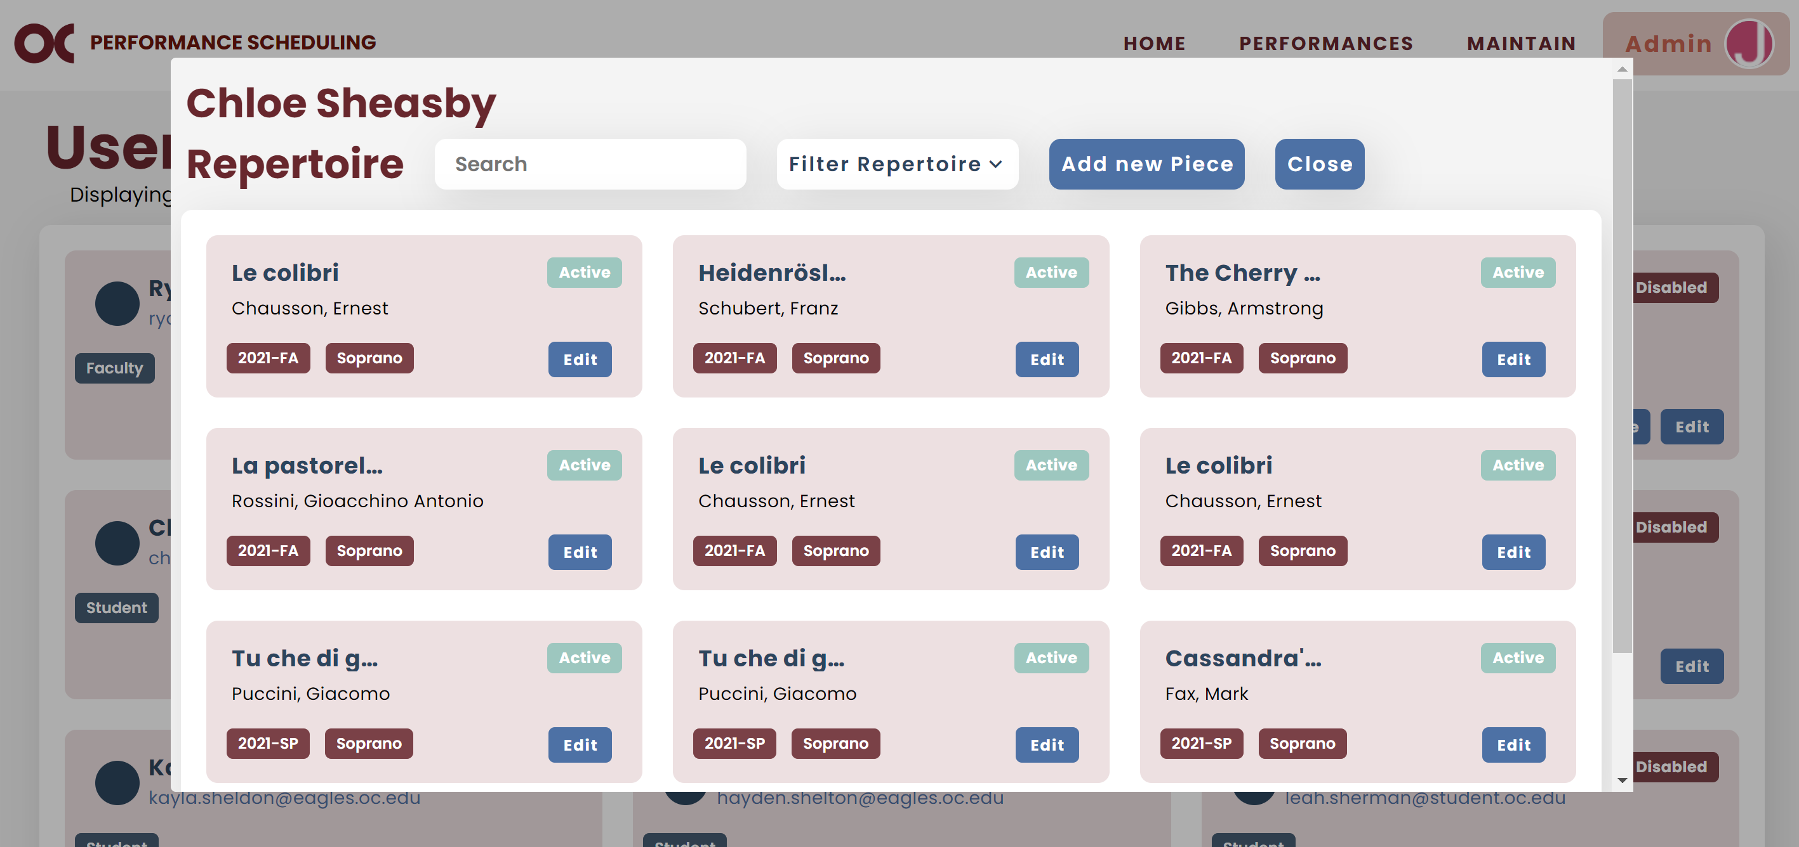

* If you want to disable a user, you can find them and click “Edit”. Go to the bottom of the pop up and click “Disable”.

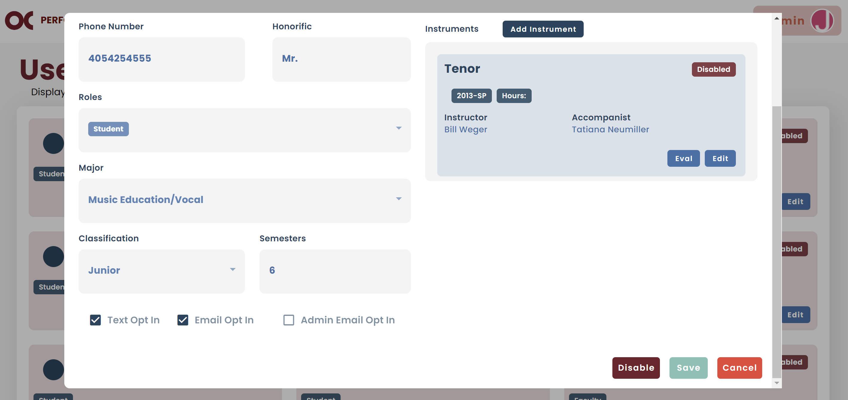

* **Note:** Disabling a user means they cannot be selected for future picks unless they are re-enabled. Their information is not deleted and remains preserved in the system.

### b. Events

* You can view all events on your Maintain Events screen.



* You can filter them by semester and location.

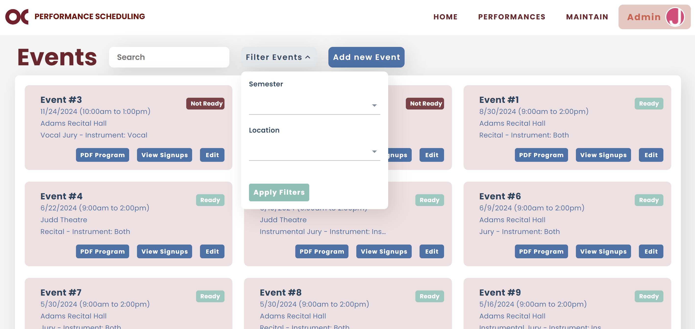

* If you want to add a new user, click on “Add new Event ”.

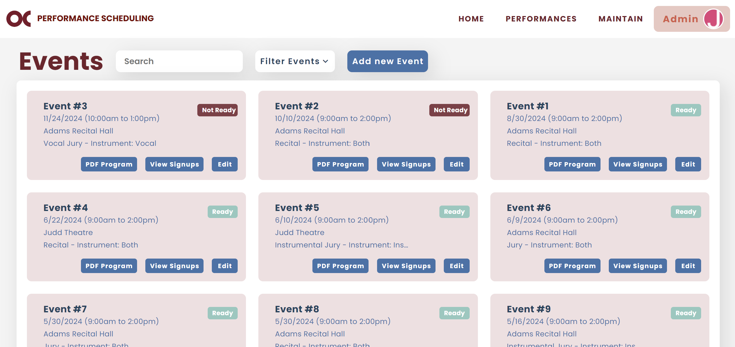

* 1. To add a new event, fill out all the fields.
  2. The “Event Name” field refers to the name of the event that you want to be displayed on the system.
  3. The “Program Name" field refers to the name that you want to be displayed on recitals program.
* If you want to edit event information, click on “Edit”.



* The "PDF Program" button generates a PDF listing the students who received a "Passed" grade for a given event. This feature is frequently used after Recital Hearing events to create a program with the information of the students performing in the subsequent Recital event.
* The statuses "Ready" and "Not Ready" for an event determine who can view and sign up for it. If an event is "Not Ready," only faculty and accompanists can view it and enter their availabilities. If an event is "Ready," students, along with faculty and accompanists, can also view and sign up for it.

### Event Types

* Event Types refer to the various categories an event can fall under, such as Recital Hearing or Jury.
* You can view all event types on your Maintain Event Types screen.



* You can filter them by status, slot type or instrument type.

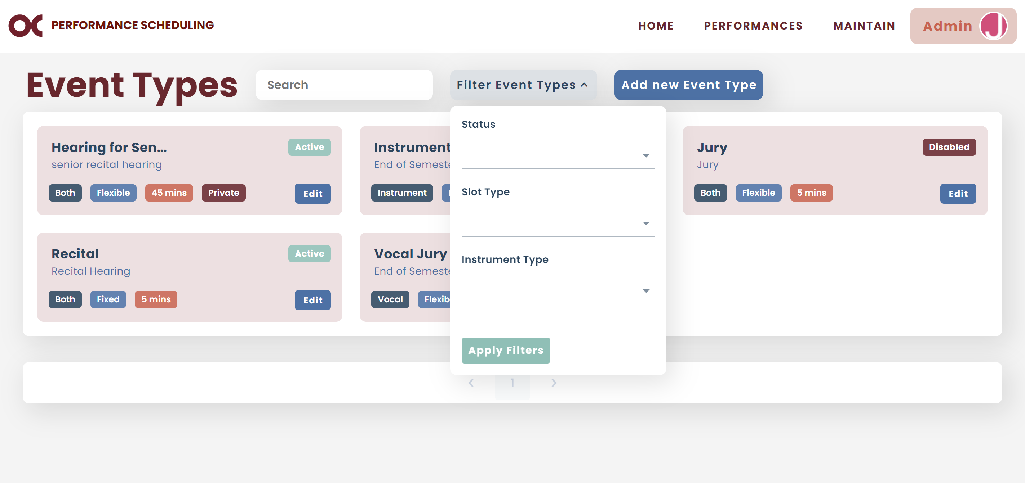

* If you want to add a new event type, click on “Add new Event Type”.

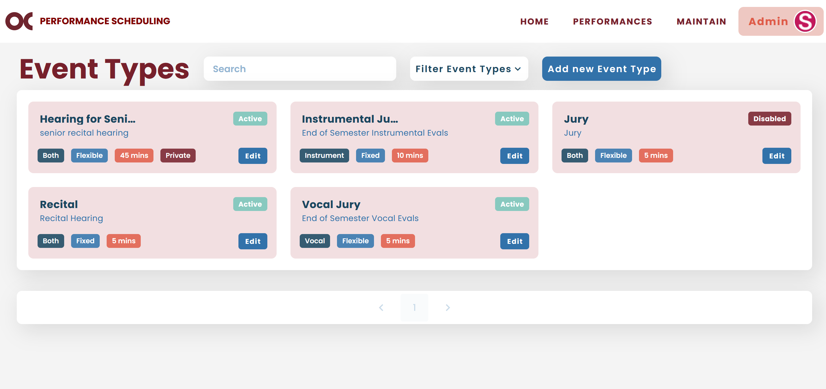

* 1. To add a new event type, fill out all the fields.
  2. The “Type” field refers to the name of the event type.
  3. The “Slot Type” field refers to the time slots students can sign up for an event. If an event type has fixed time slots (e.g., all students must sign up for 5-minute slots for Recital Hearings), you should select "Fixed." If an event allows students to sign up for different time slot durations (e.g., depending on criteria, students can sign up for 5, 10, or 15-minute slots for Jury), then you should select "Flexible."
  4. The "Instrument Type" field specifies the types of instruments for which students can sign up for this event type.
  5. The "Default Slot Duration" field indicates the amount of time, in minutes, that a student can sign up for an event. If an event type has fixed time slots, you should enter the duration of the slots (e.g., 5 minutes for Recital Hearings). If an event type has flexible time slots, you should enter the lowest slot duration (e.g., 5 minutes for Vocal Jury).
  6. **Note:** The system automatically calculates the time slot duration for each student based on the criteria set by the music department for flexible time slots. If a student does not meet the criteria, the default time slot duration will be used instead.
  7. The “Event Privacy” checkbox should be selected if the event type is meant for individual student performances (e.g., Senior Recital Hearings).
  8. The “Grade Allowed” checkbox should be selected if the event type requires private instructors to evaluate whether a student passed or failed their performance (e.g., Recital Hearings).
  9. The “First Piece Required” checkbox should be selected if the event type requires students to provide which piece they are performing first (e.g., Jury).
  10. The “Ending Level Allowed” checkbox should be selected if the event type requires private instructors to evaluate a student instrument level after their performance (e.g., Jury).
* If you want to edit event information, click on “Edit”.



* If you want to disable an event type, you can find it and click “Edit”. Go to the bottom of the pop up and click “Disable”.

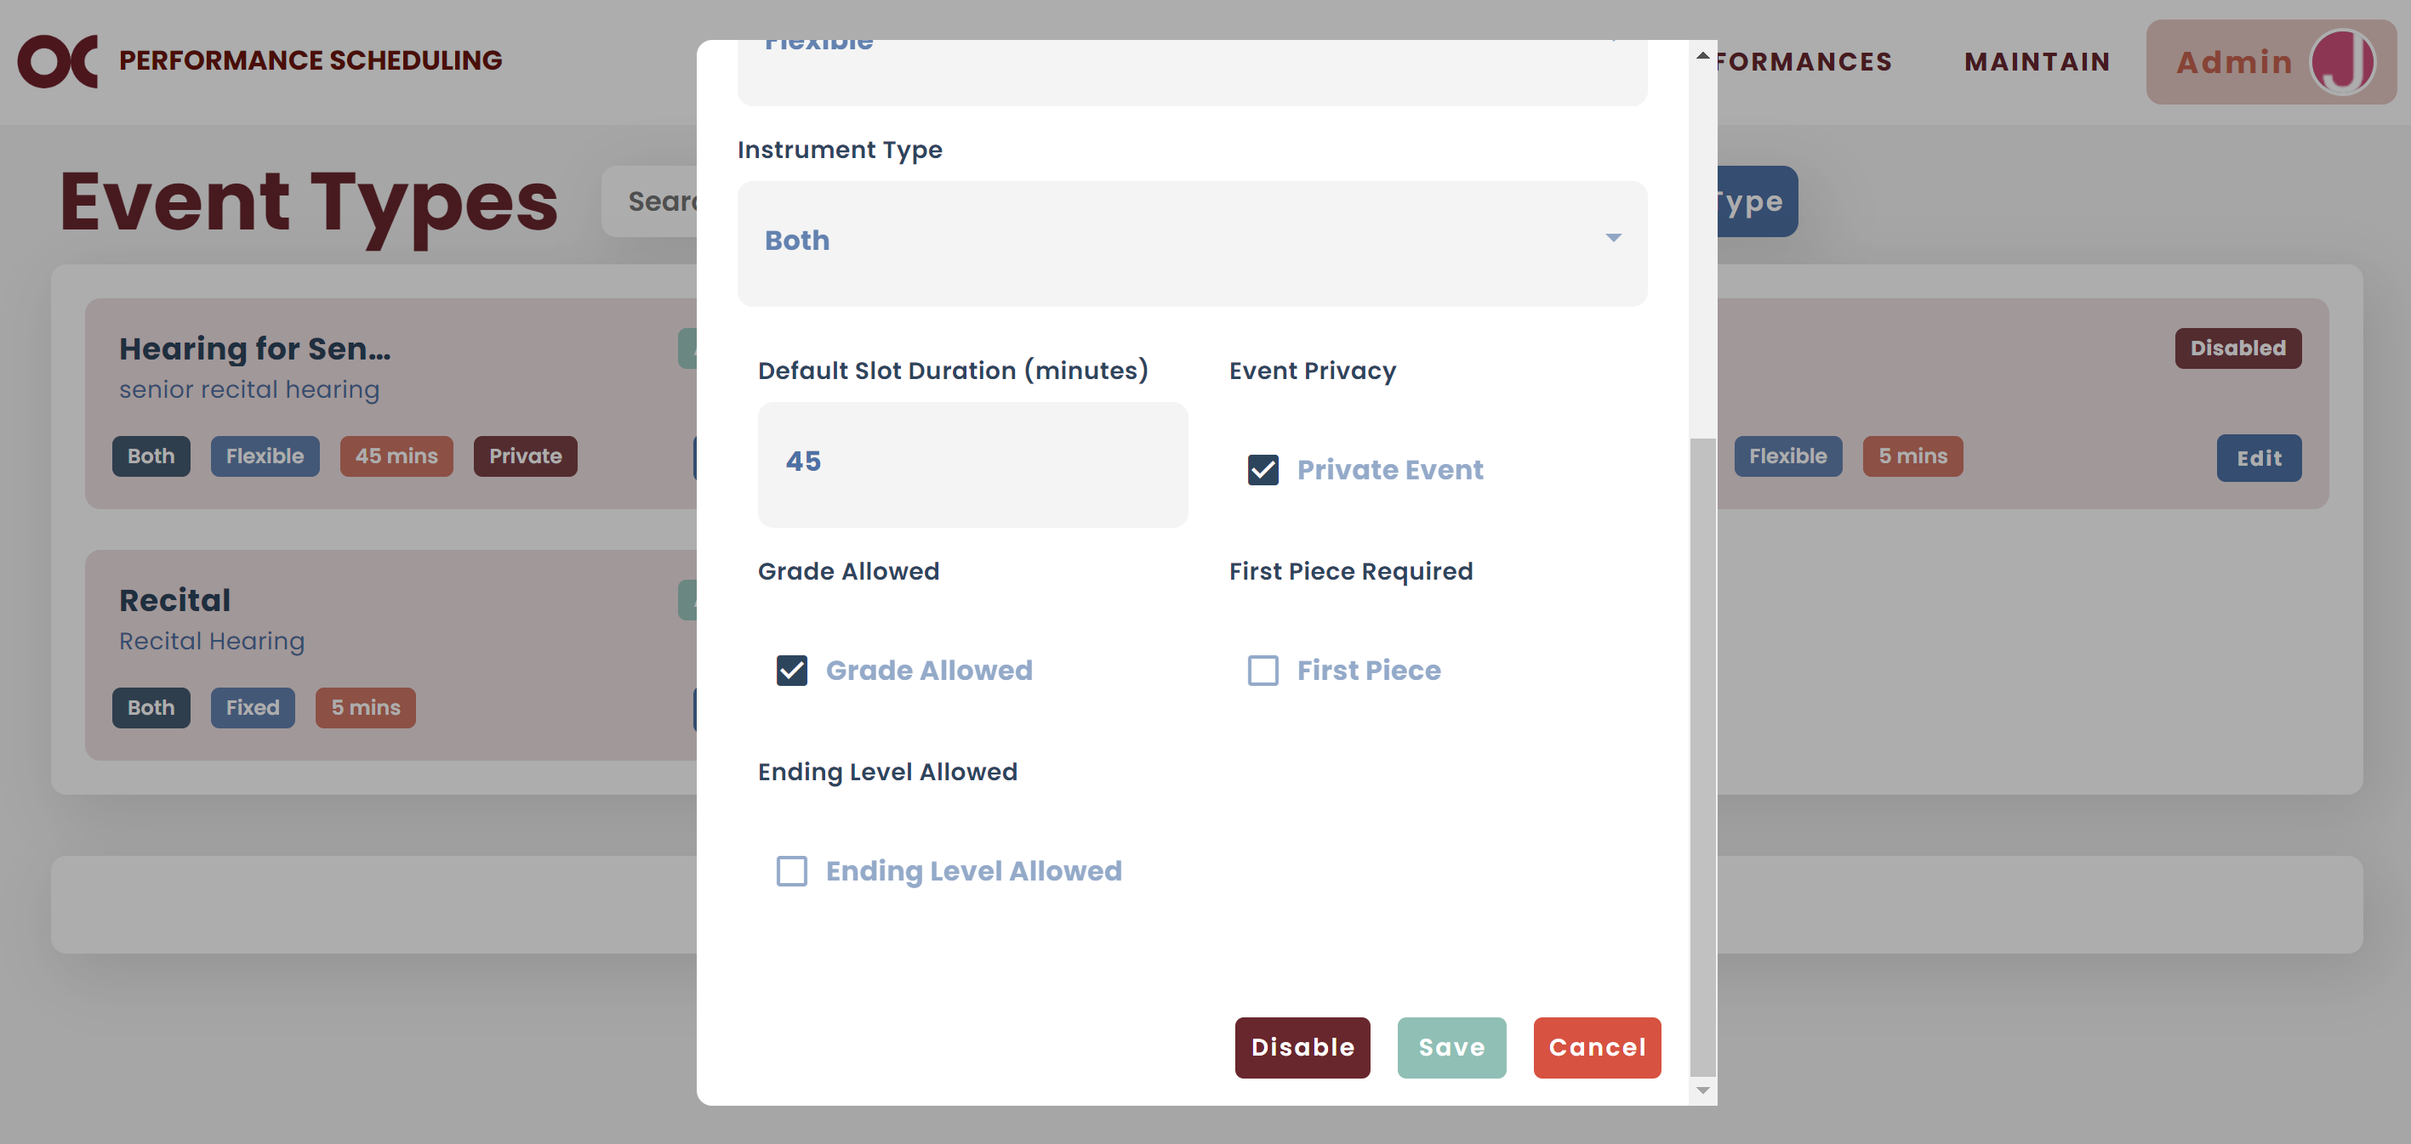

* **Note:** Disabling an event type means it cannot be selected for future picks unless they are re-enabled. Its information is not deleted and remains preserved in the system.

### Instruments

* Instruments refer to the different types of vocals and instruments.
* You can view all instruments on your Maintain Instruments screen.



* You can filter them by status or instrument type.

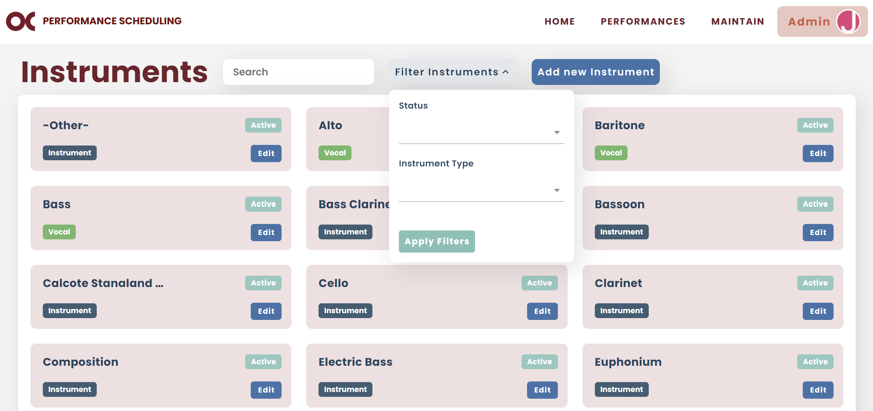

* If you want to add a new instrument, click on “Add new Instrument”.

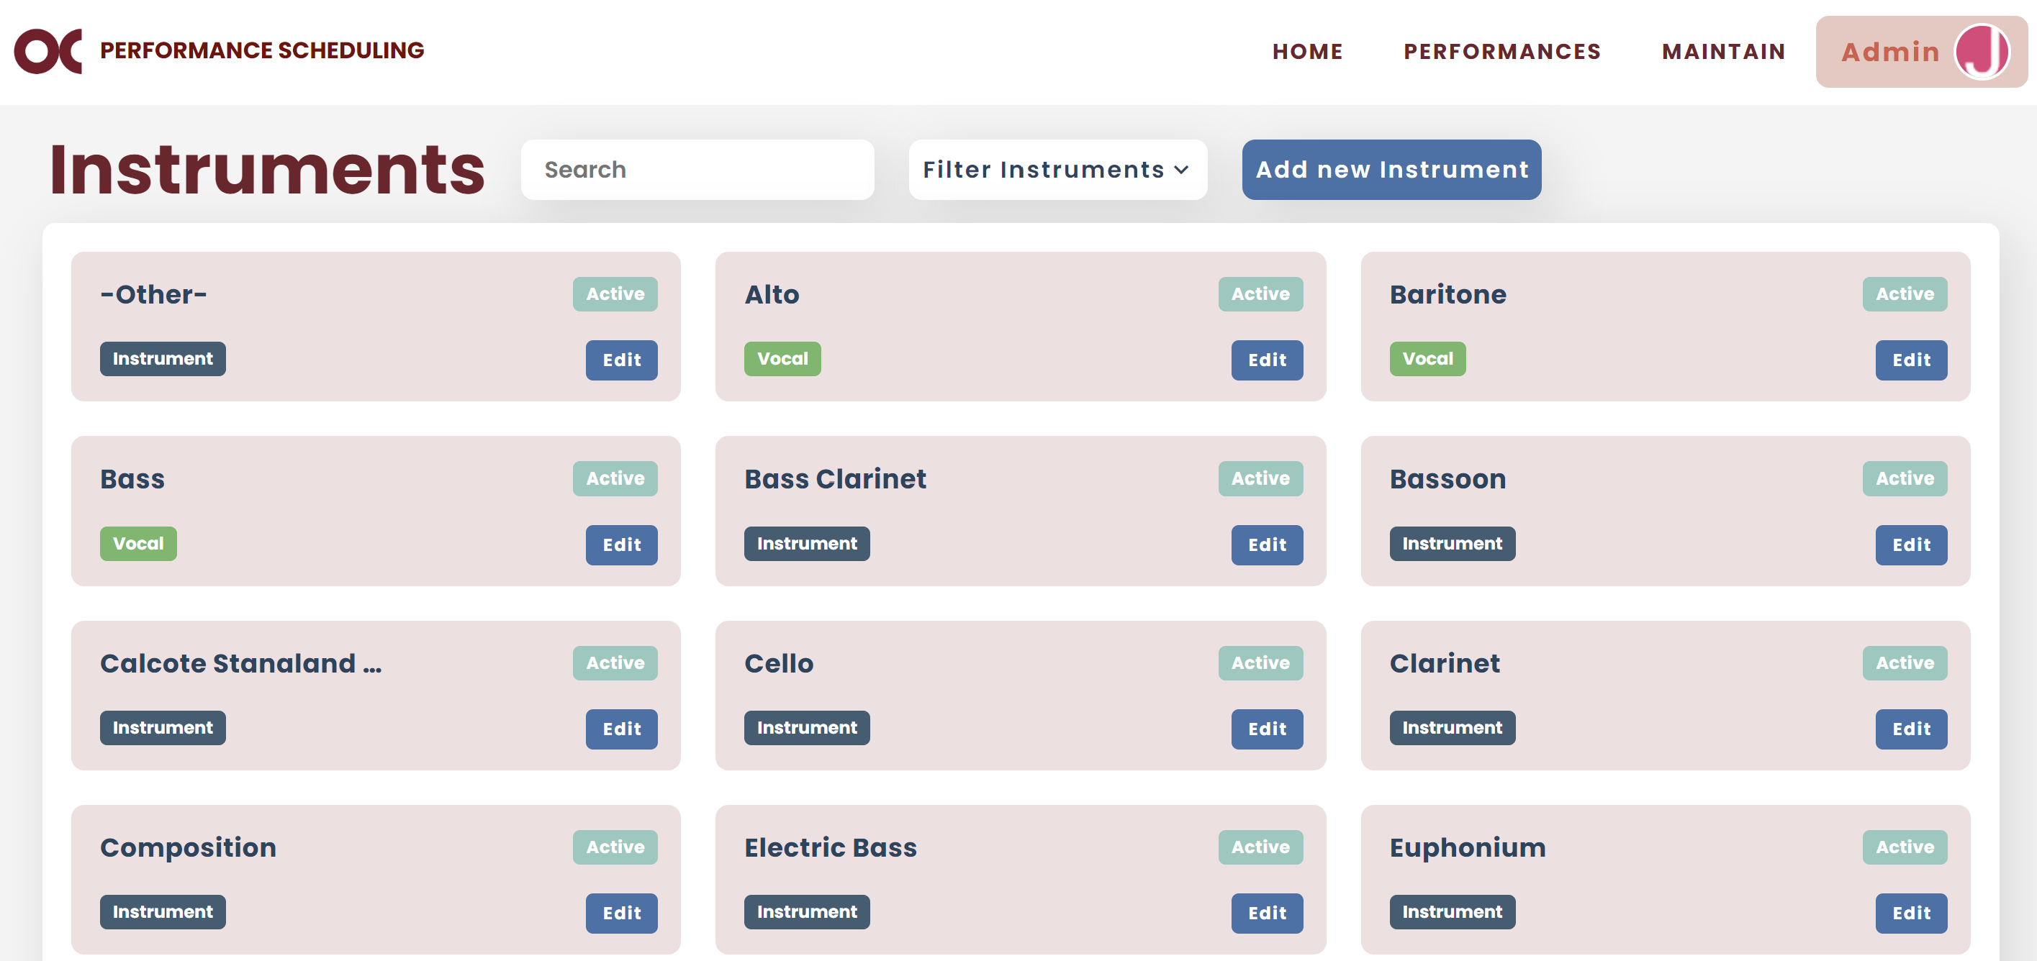

* If you want to edit instrument information, click on “Edit”.



* If you want to disable an instrument, you can find it and click “Edit”. Go to the bottom of the pop up and click “Disable”.

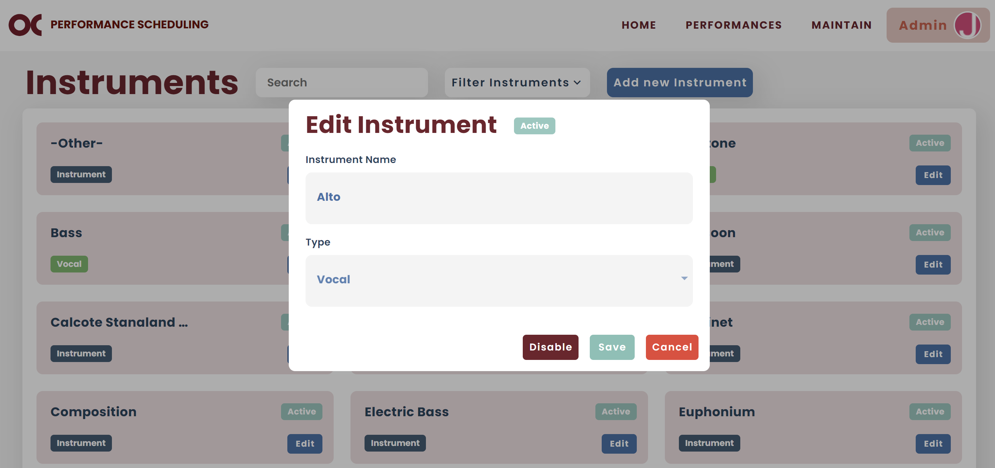

* **Note:** Disabling an instrument means it cannot be selected for future picks unless they are re-enabled. Its information is not deleted and remains preserved in the system.

### Composers

* You can view all composers on your Maintain Composers screen.



* You can filter them by status.

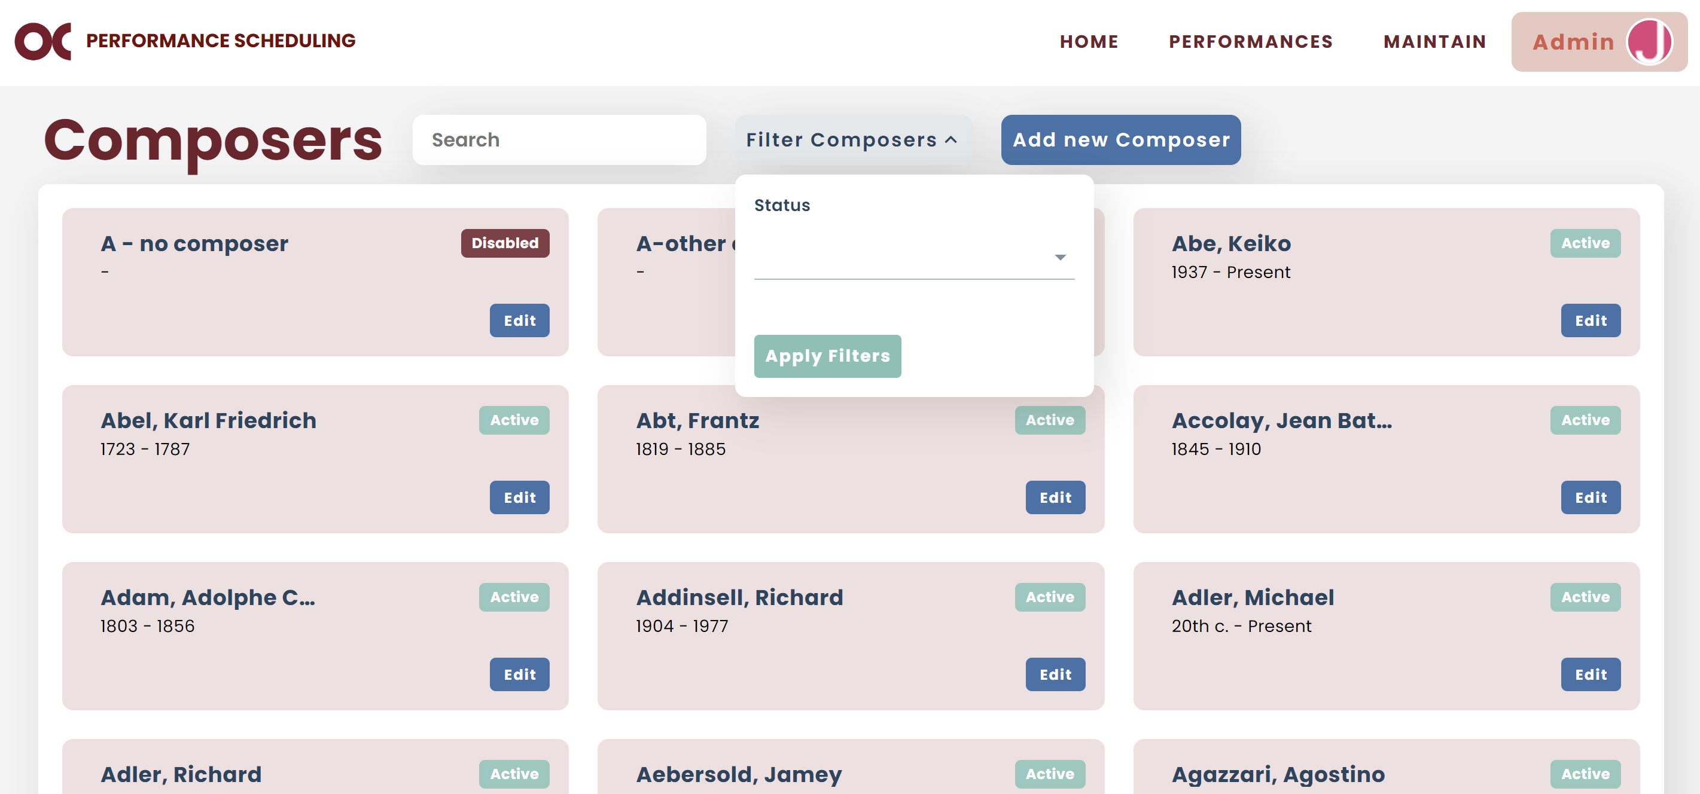

* 1. A pending status means a user added a composer to the system and it’s been waiting for an admin to approve it or not.

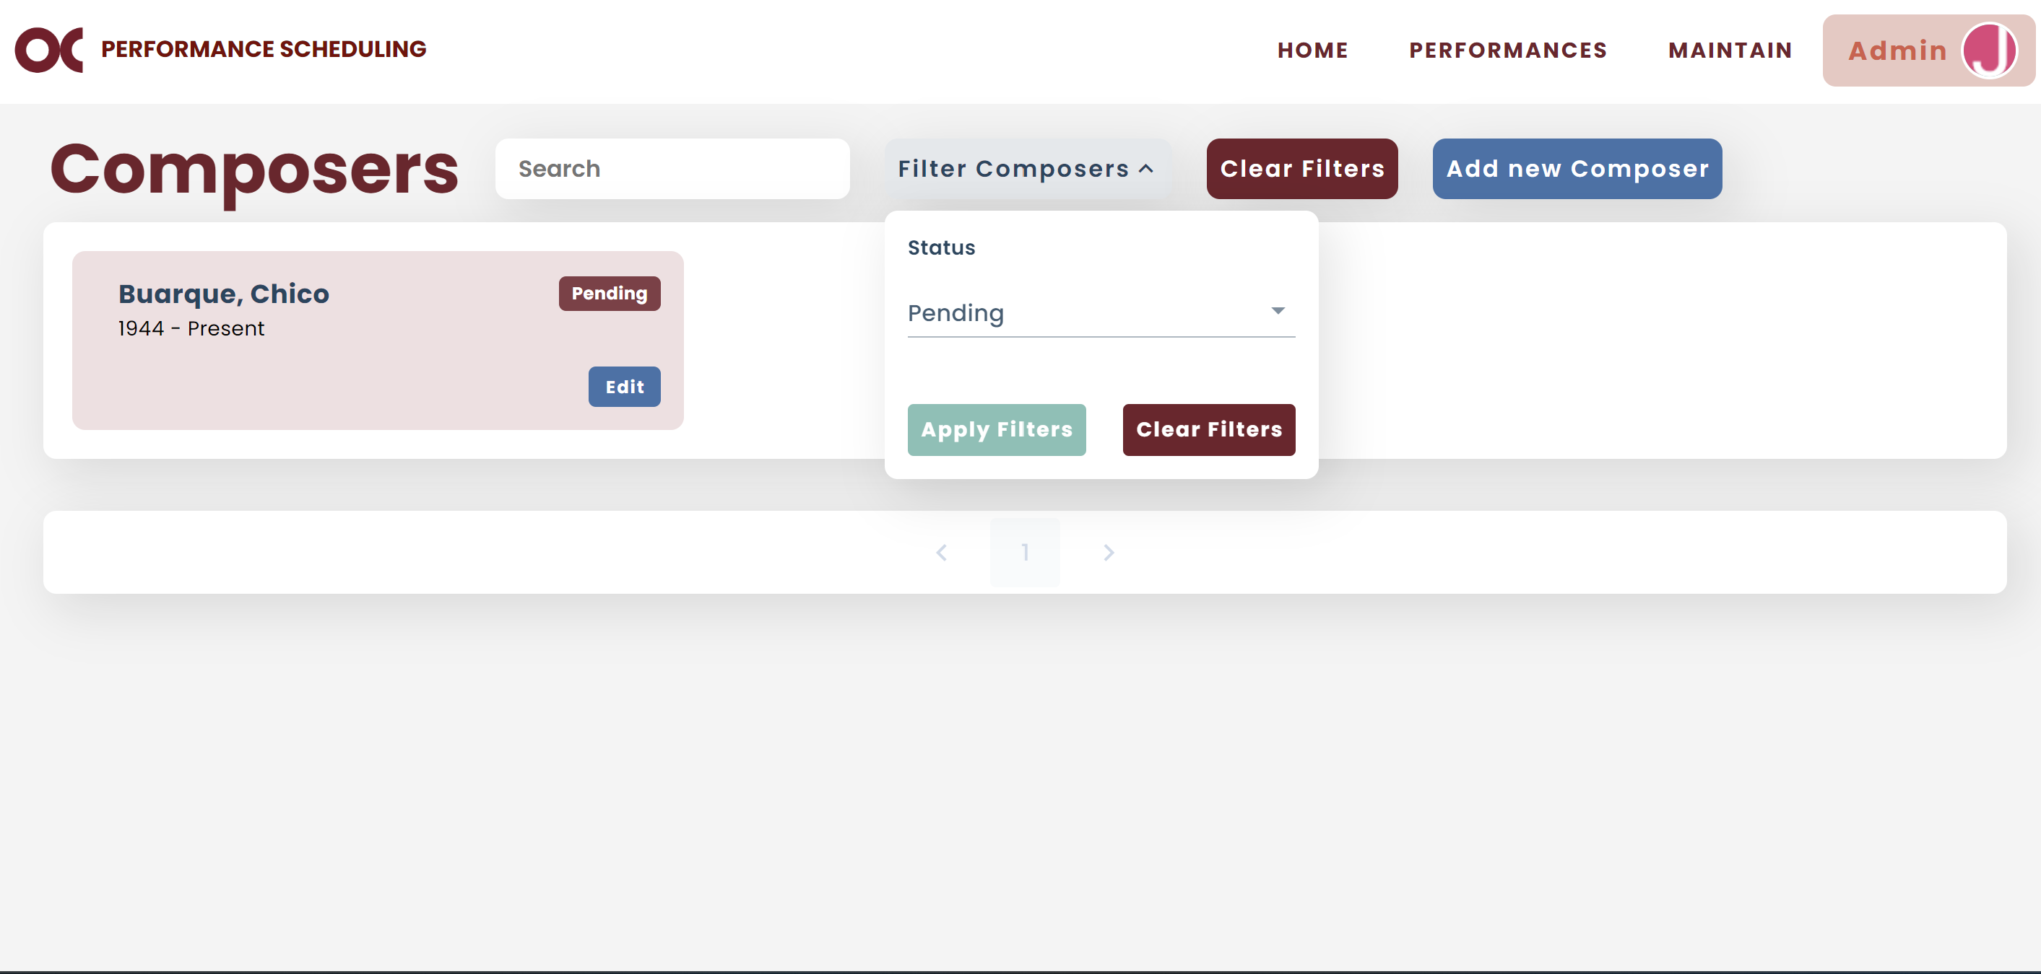

* 1. You can approve it by clicking on “Edit” and then “Enable” on the bottom of the pop up.

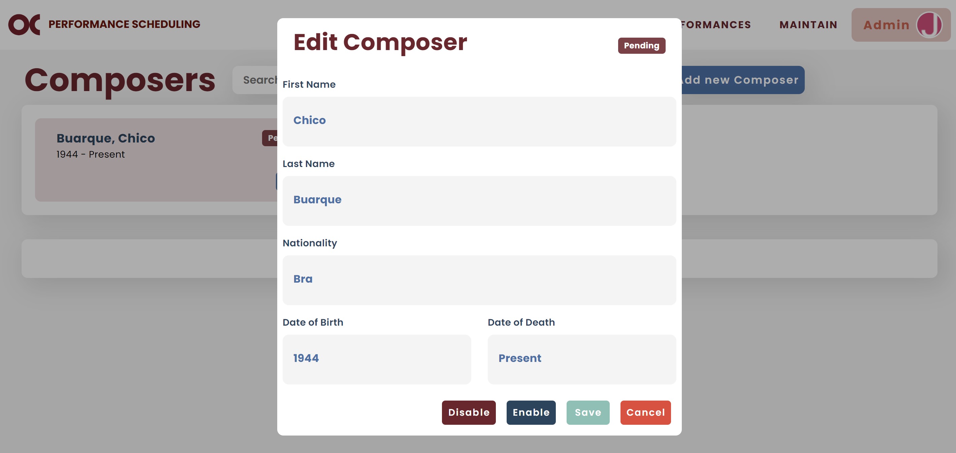

* 1. If you don’t want to approve (e.g., this composer already exists), you can select “Disable”.
* If you want to add a new composer, click on “Add new Composer”.

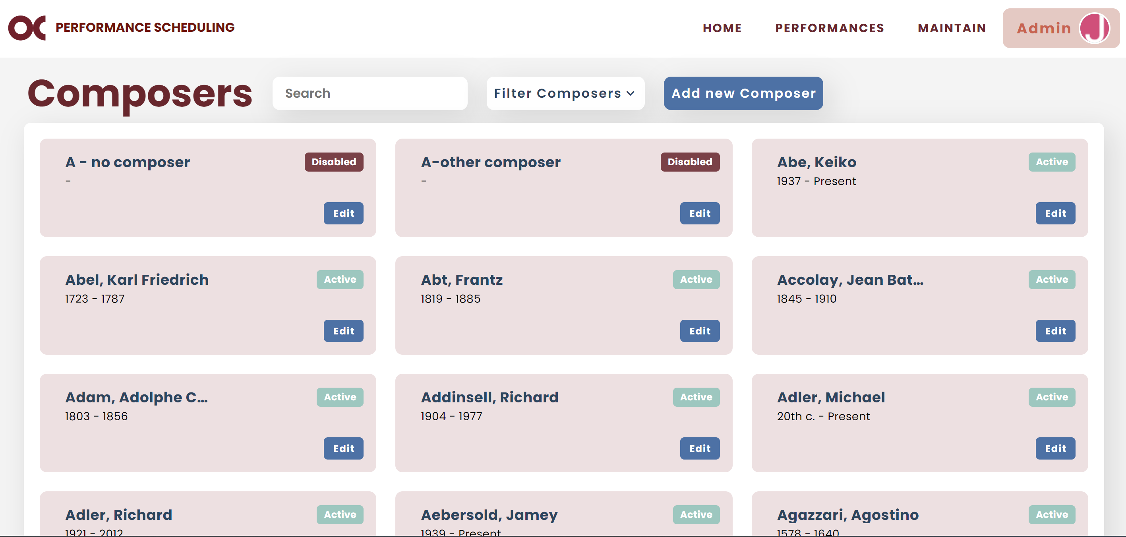

* If you want to edit composer information, click on “Edit”.



* If you want to disable a composer, you can find it and click “Edit”. Go to the bottom of the pop up and click “Disable”.

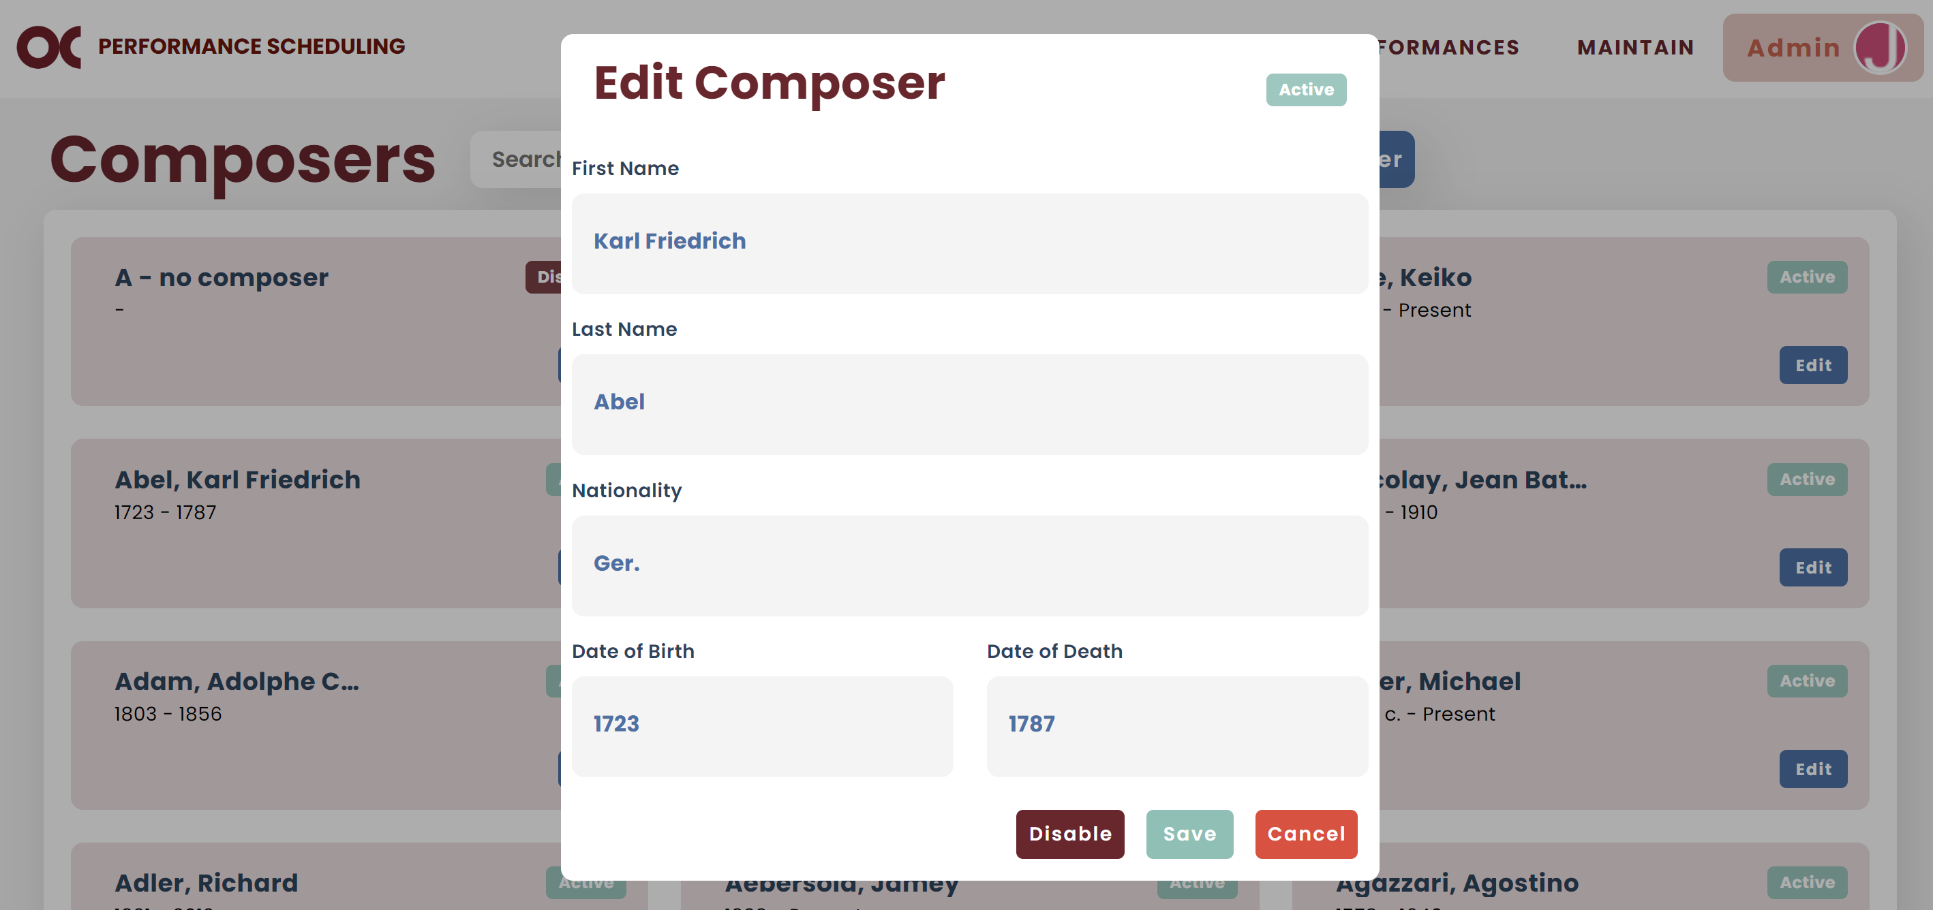

* **Note:** Disabling a composer means it cannot be selected for future picks unless they are re-enabled. Its information is not deleted and remains preserved in the system.

### Pieces

* You can view all pieces on your Maintain Pieces screen.



* You can filter them by status.

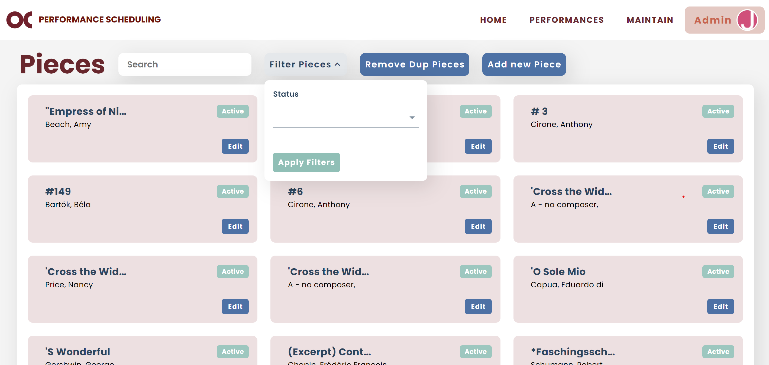

* 1. A pending status means a user added a piece to the system and it’s been waiting for an admin to approve it or not.

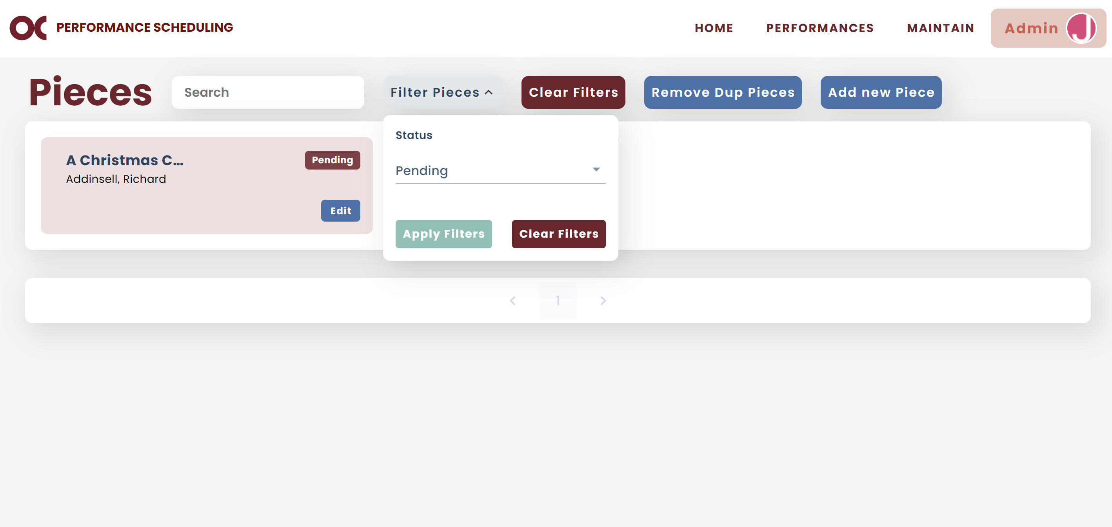

* 1. You can approve it by clicking on “Edit” and then “Enable” on the bottom of the pop up.

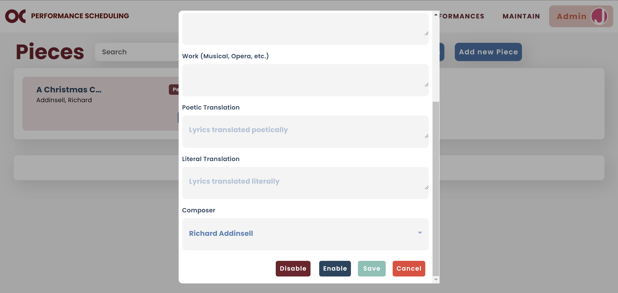

* 1. If you don’t want to approve (e.g., this piece already exists), you can select “Disable”.
* If you want to add a new piece, click on “Add new Piece”.

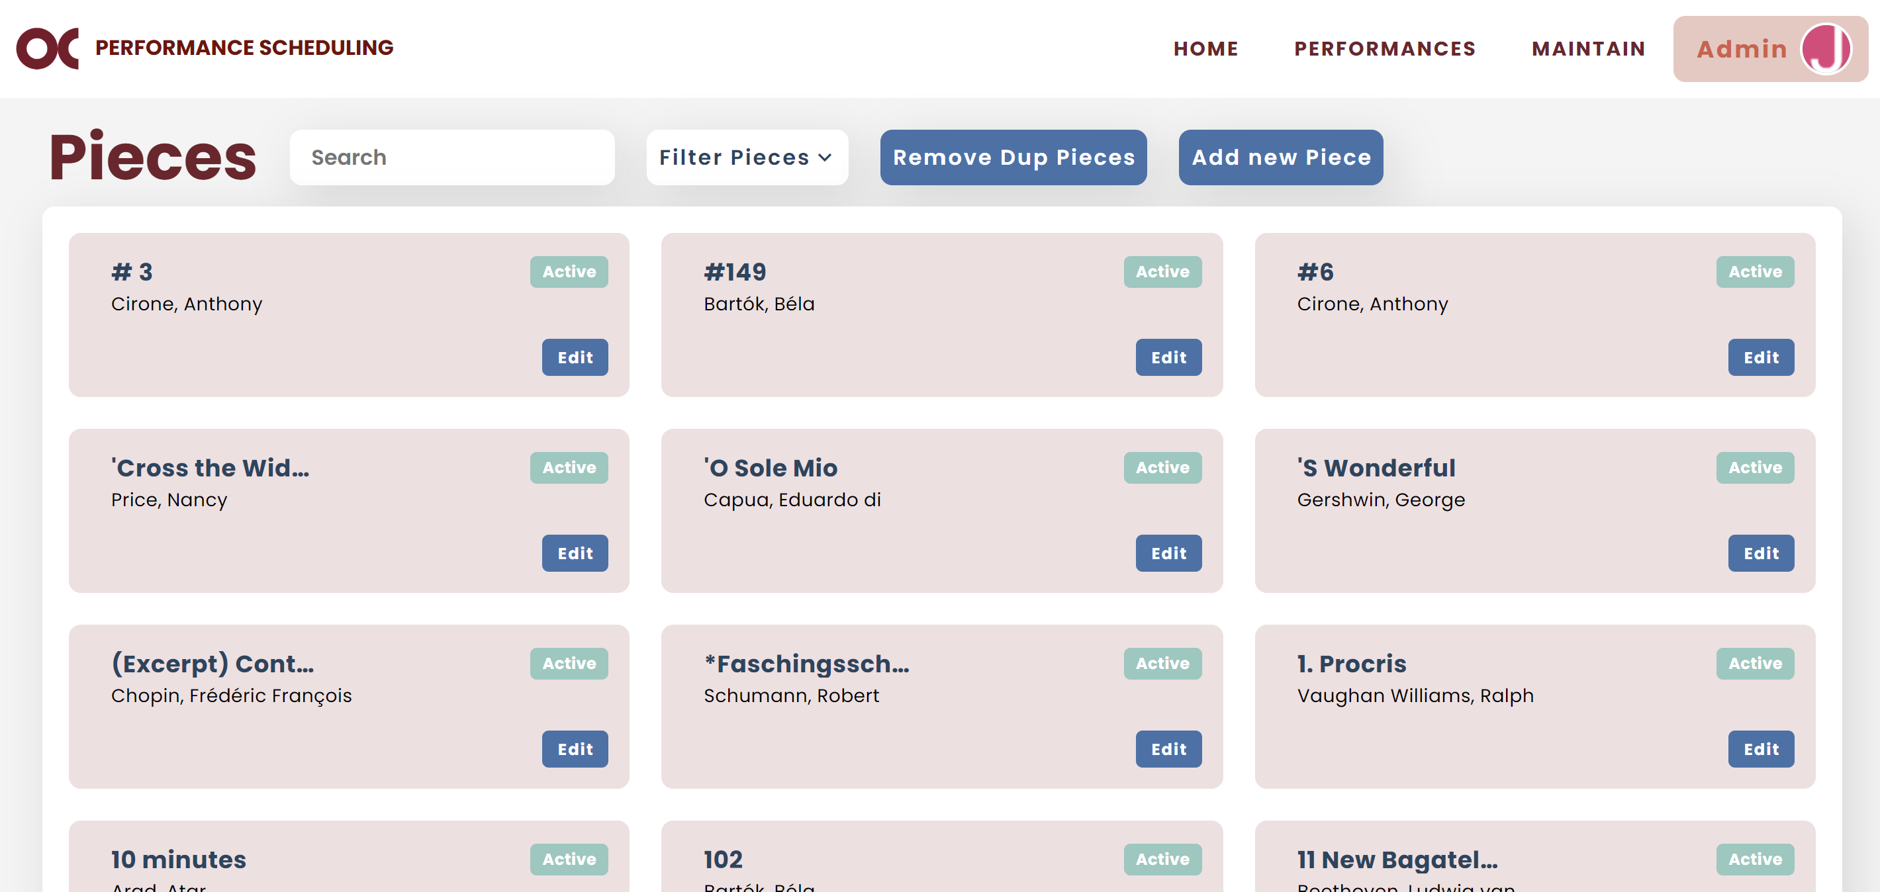

* If you want to edit piece information, click on “Edit”.



* If you want to disable a piece, you can find it and click “Edit”. Go to the bottom of the pop up and click “Disable”. (PICTURE)

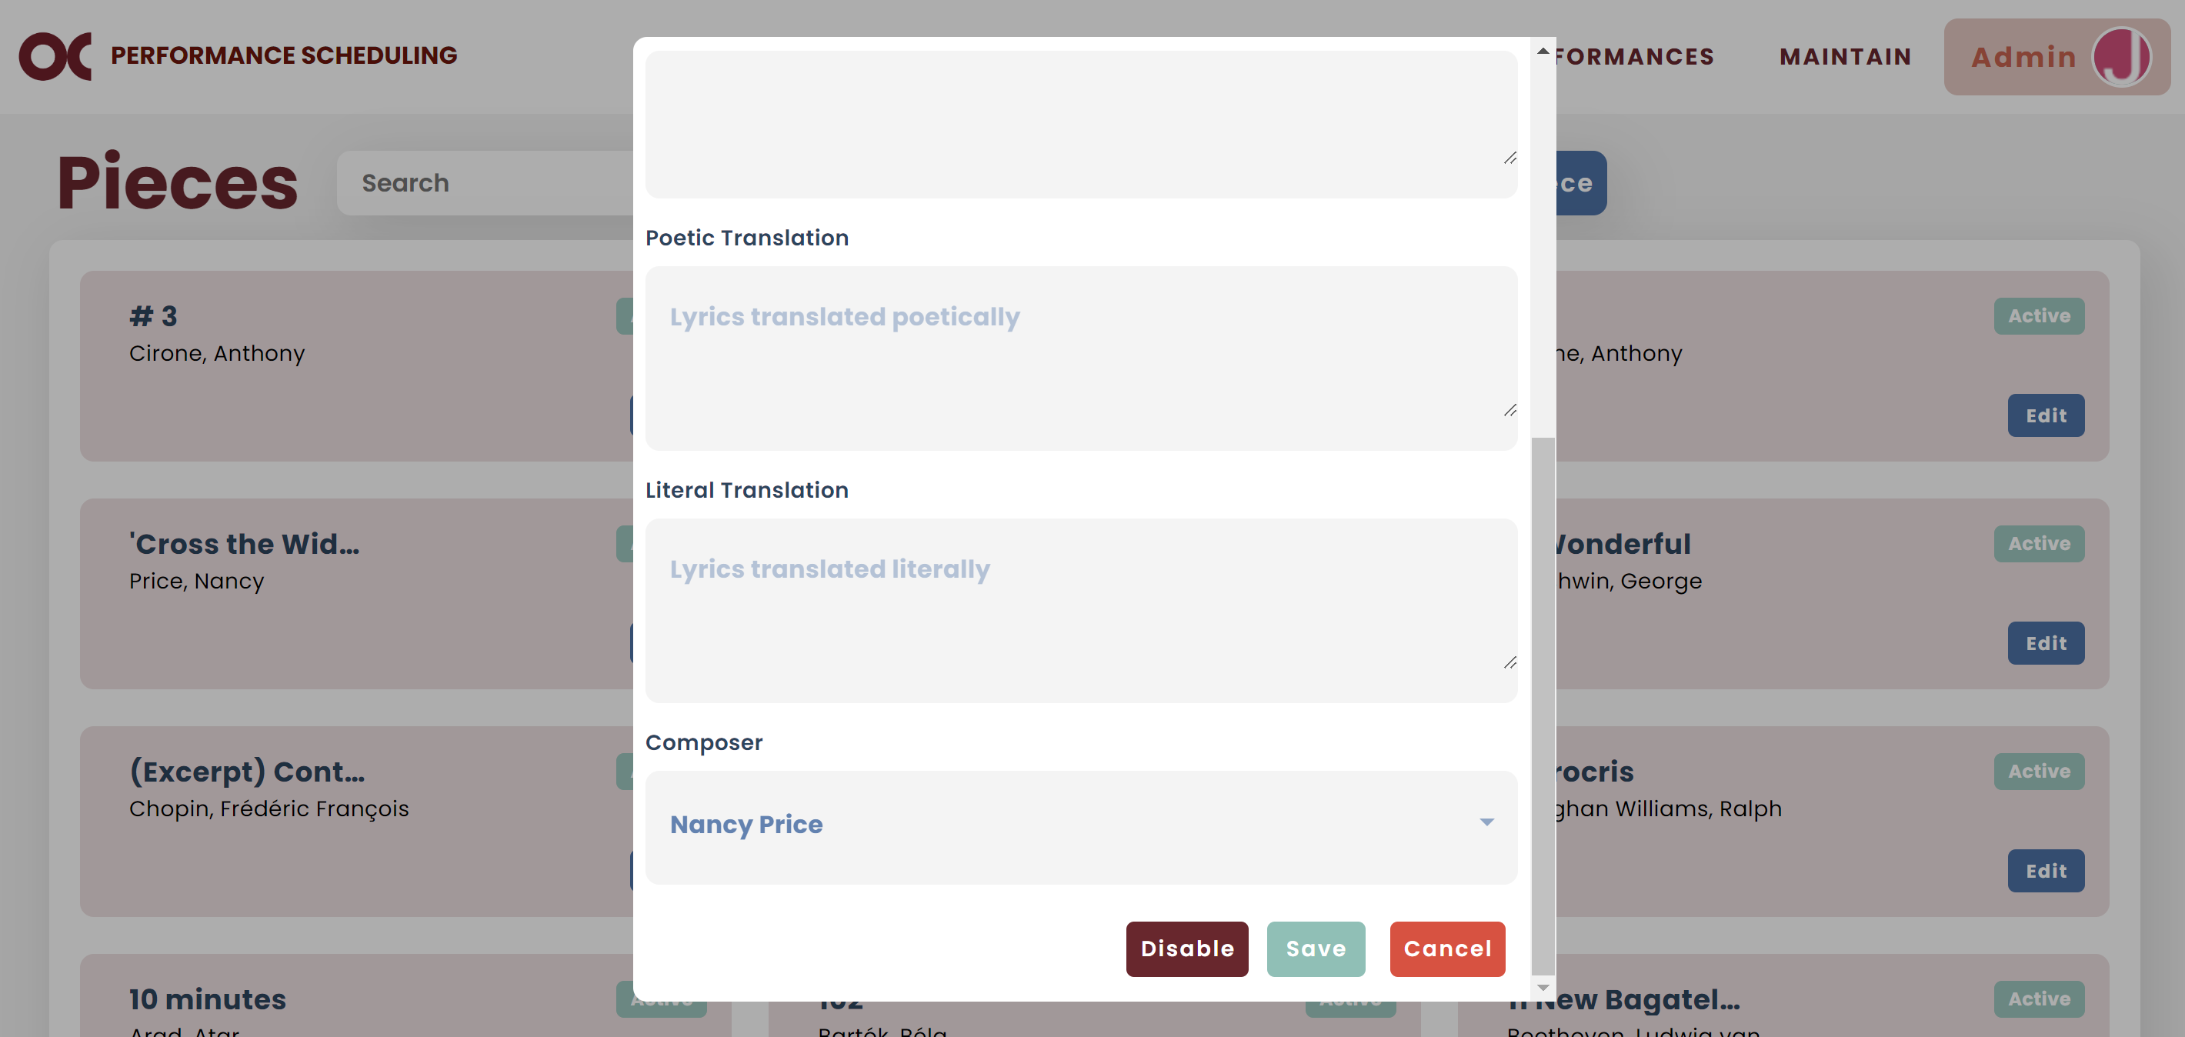

* **Note:** Disabling a piece means it cannot be selected for future picks unless they are re-enabled. Its information is not deleted and remains preserved in the system.
* If you find pieces that are duplicated, click on “Remove Dup Pieces”.



* Then, type the composer and find the pieces. Select all repeated ones, go to the bottom of the pop up and click “Merge Duplicates”.

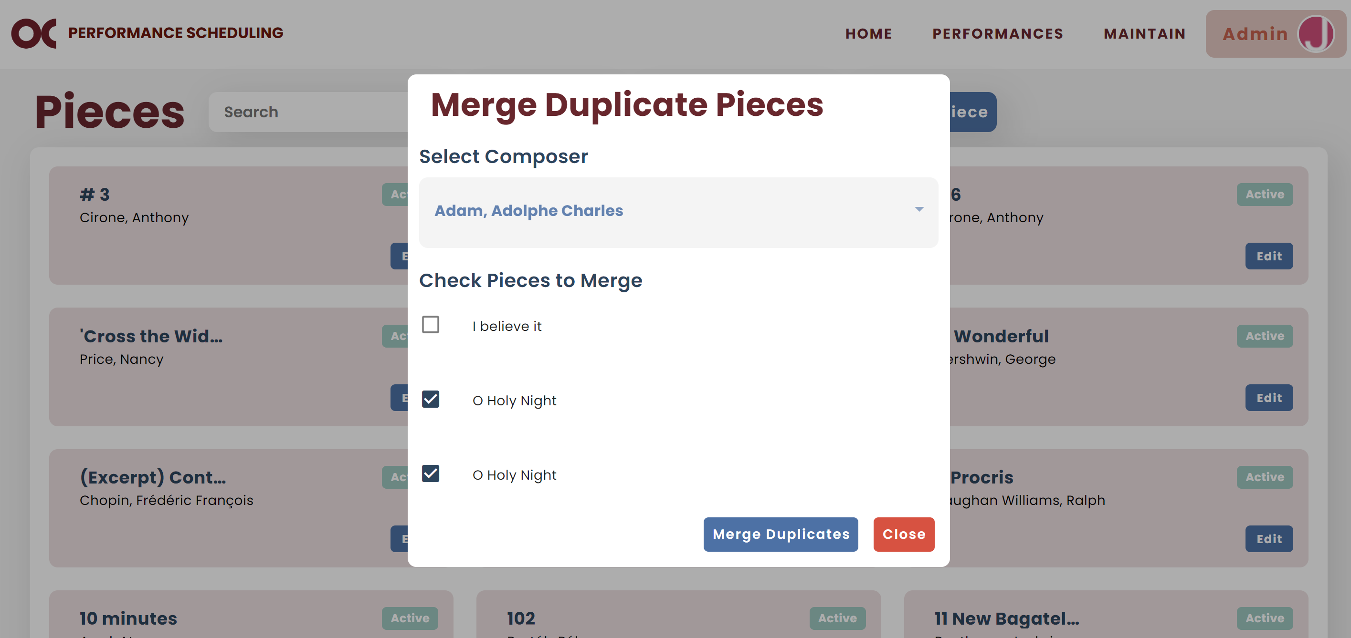

* **Note:** The first piece among the repeated ones on the list will be the one that remains after merging.

### Majors

* You can view all majors on your Maintain Majors screen.



* You can filter them by status or major type.

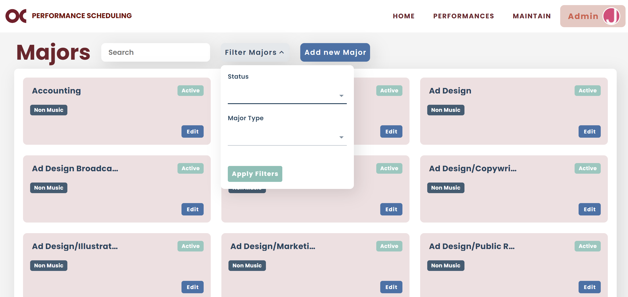

* If you want to add a new major, click on “Add new Major”.

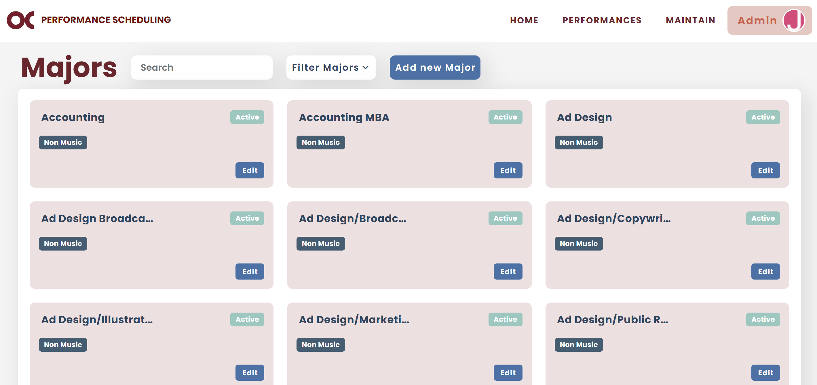

* If you want to edit major information, click on “Edit”.



* If you want to disable a major, you can find it and click “Edit”. Go to the bottom of the pop up and click “Disable”.

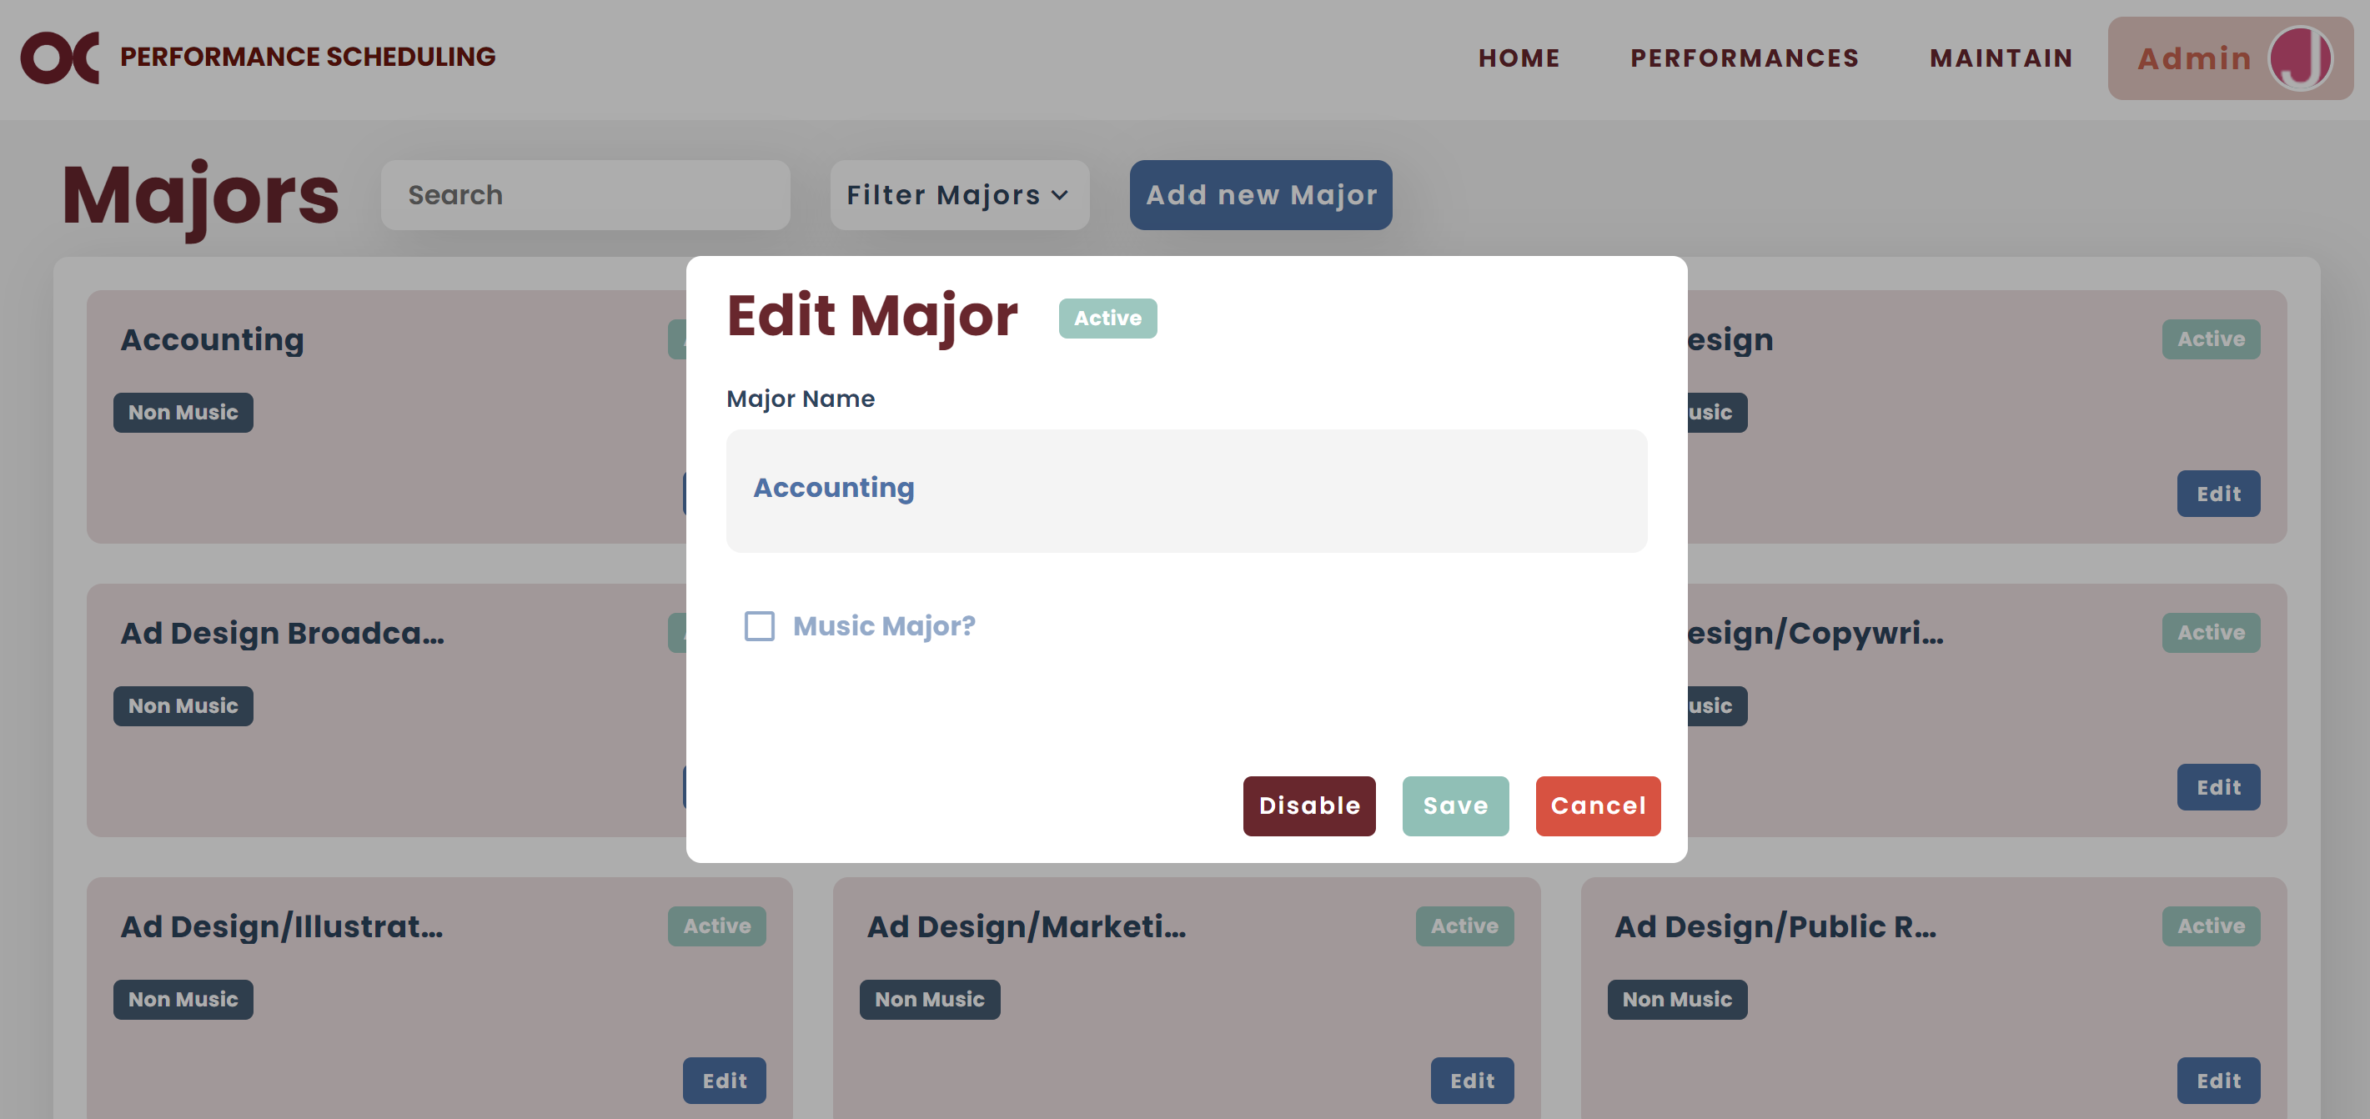

* **Note:** Disabling a major means it cannot be selected for future picks unless they are re-enabled. Its information is not deleted and remains preserved in the system.

### Levels

* Levels refer to the different types of levels a vocal student can achieve.
* You can view all levels on your Maintain Levels screen.



* If you want to add a new level, click on “Add new Level”.

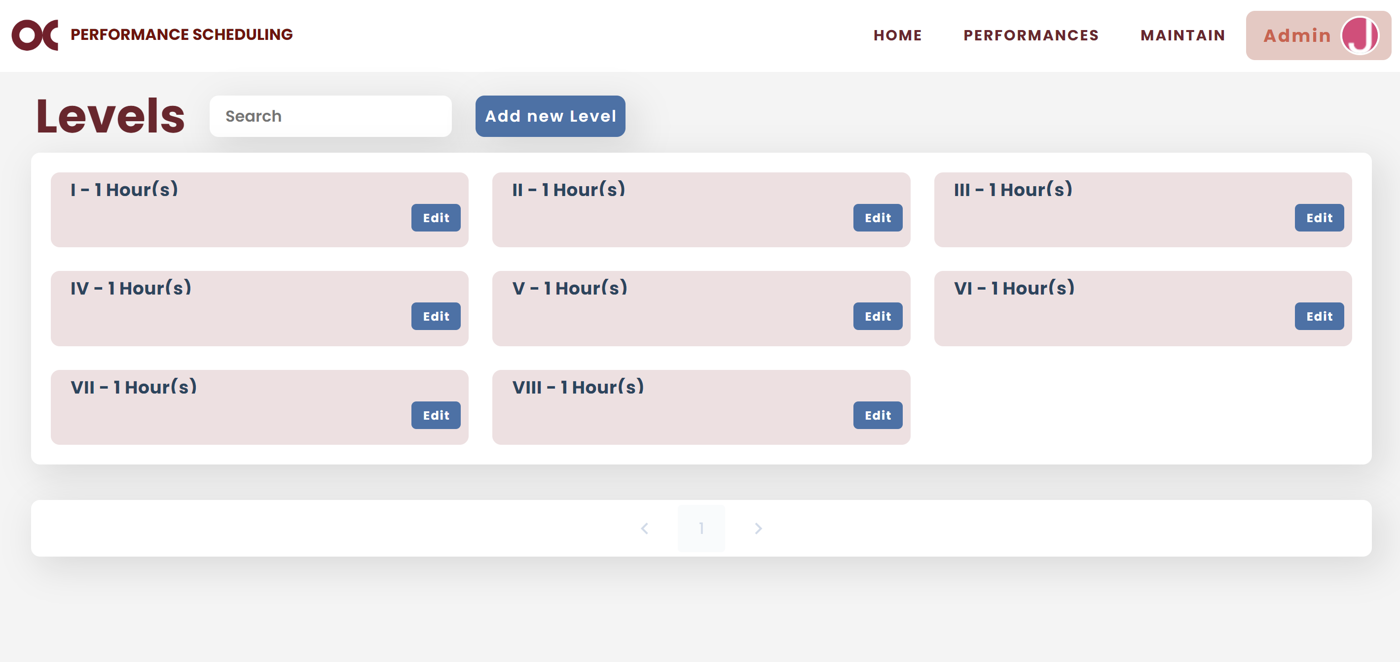

* 1. To add a new level, fill out all the fields.
  2. The "Name" field indicates the level number, usually in Roman numerals.
  3. The "Hours" field refers to the number of credit hours related to that level.
* If you want to edit level information, click on “Edit”.



### Semesters

* You can view all semesters on your Maintain Semesters screen.



* If you want to add a new semester, click on “Add new Semester”.

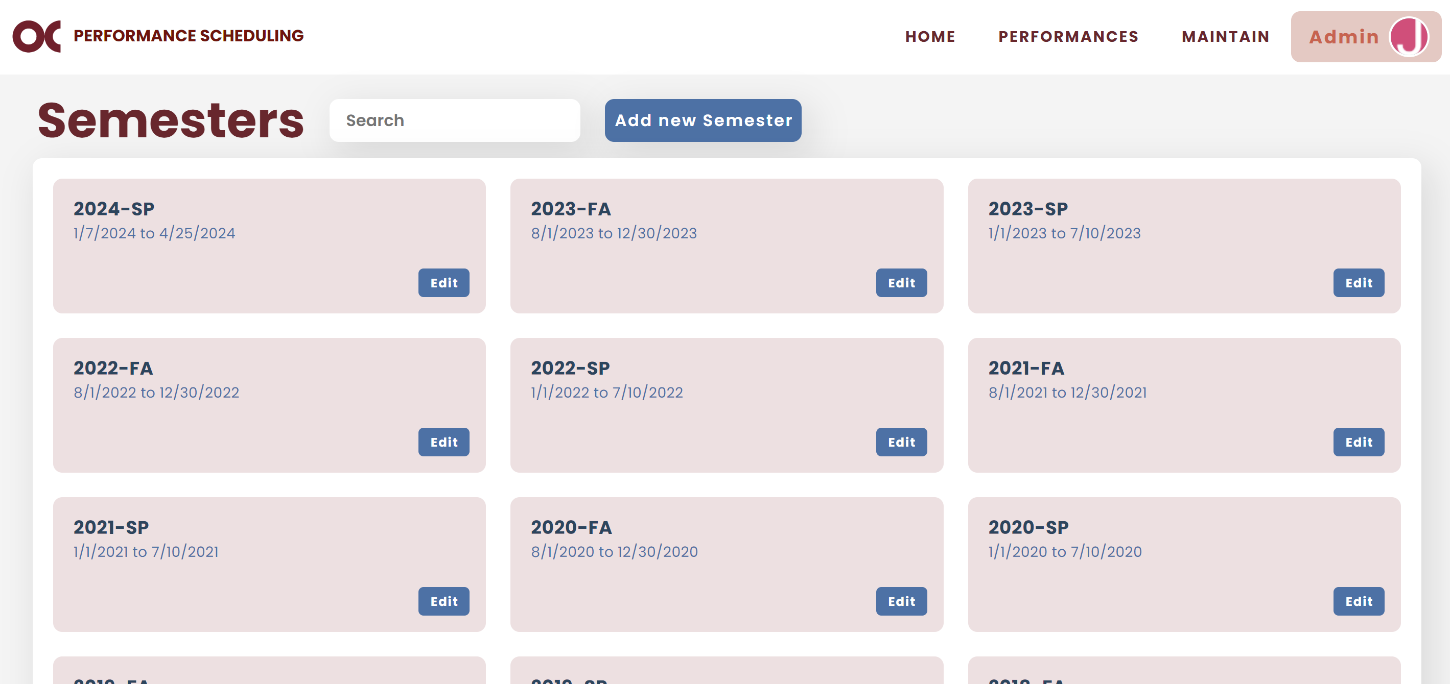

* 1. To add a new semester, fill out all the fields.
  2. The “Disable all Students” checkbox is used at the beginning of each semester. When selected, it disables all students upon creating a new semester. Students are reactivated when they log in to the system, ensuring that only students performing in the current semester are active in the system.
* If you want to edit semester information, click on “Edit”.



### Locations

* Locations refer to the different places where an event can happen.
* You can view all locations on your Maintain Locations screen.



* You can filter them by status.

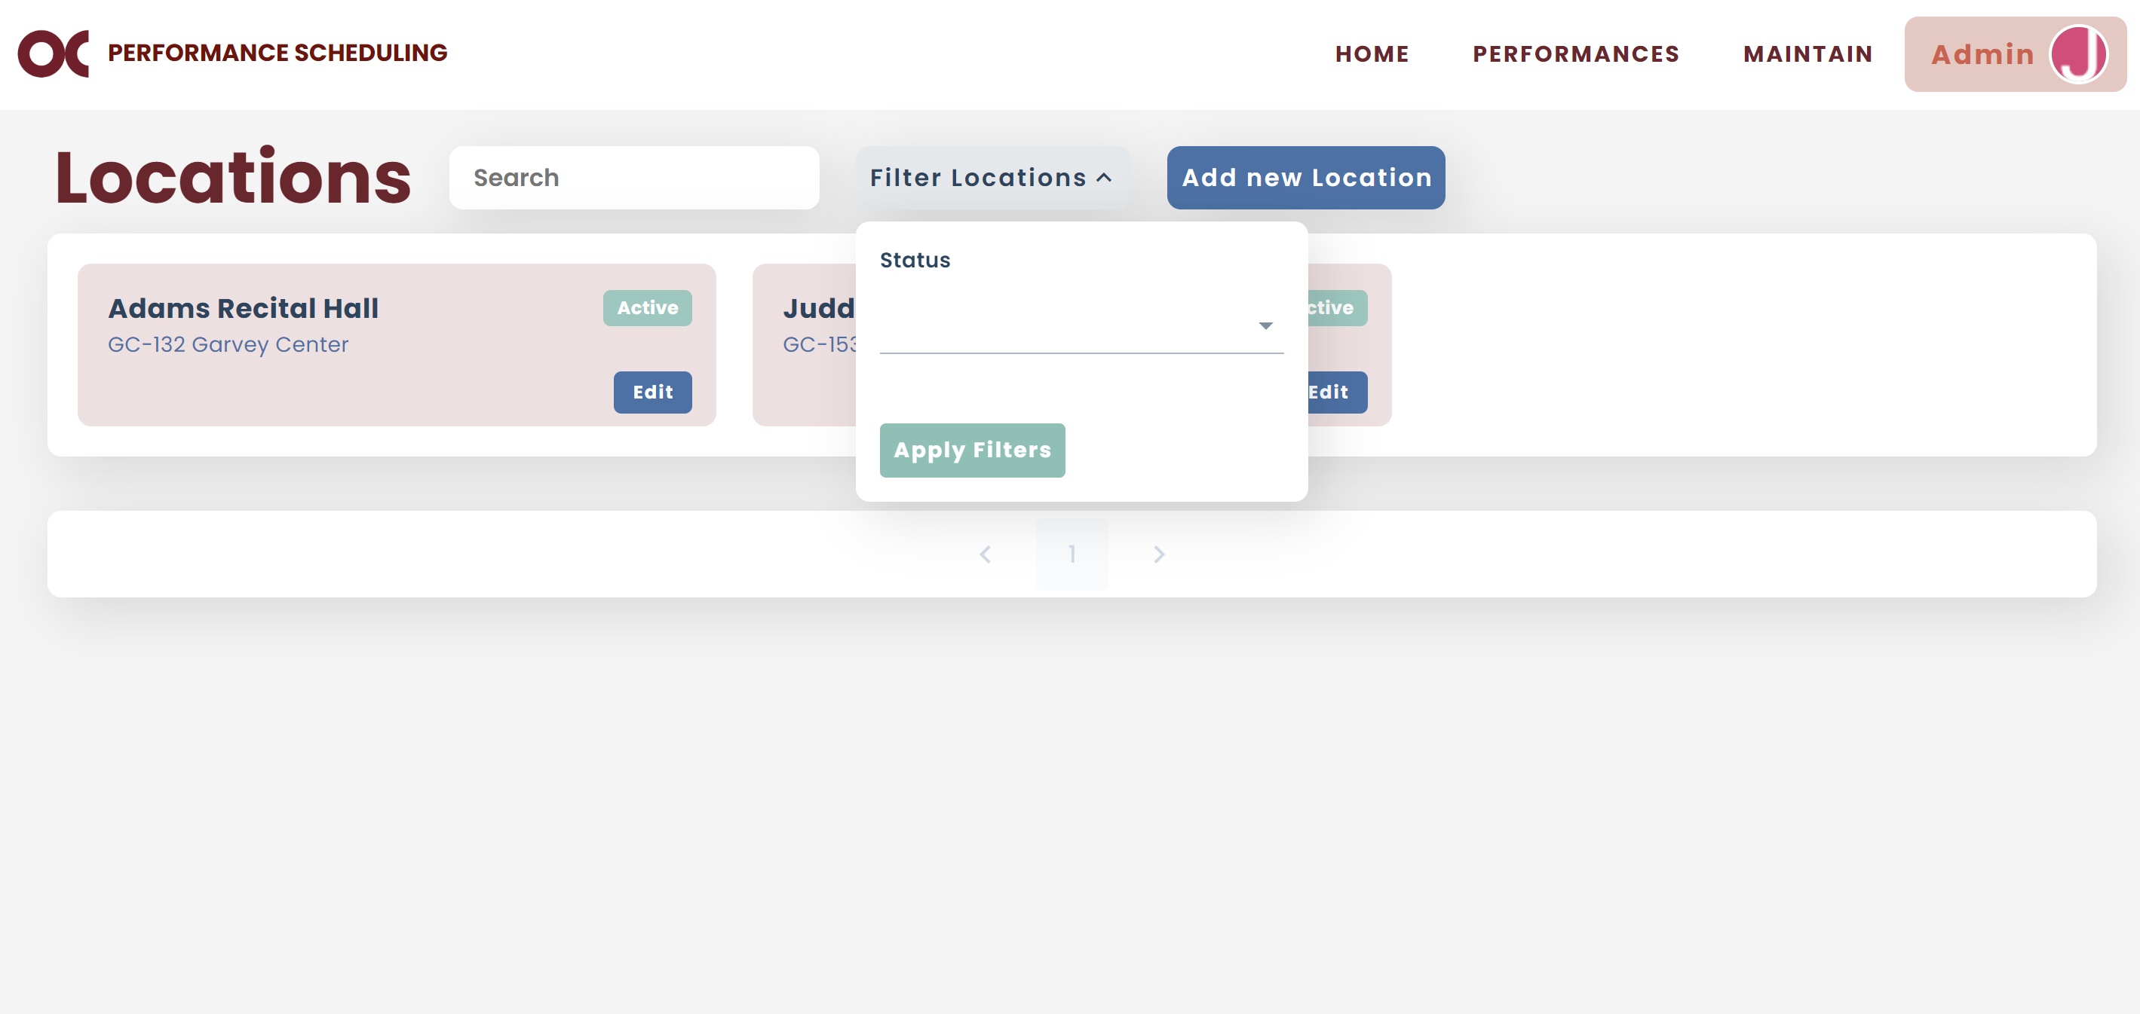

* If you want to add a new location, click on “Add new Location”.

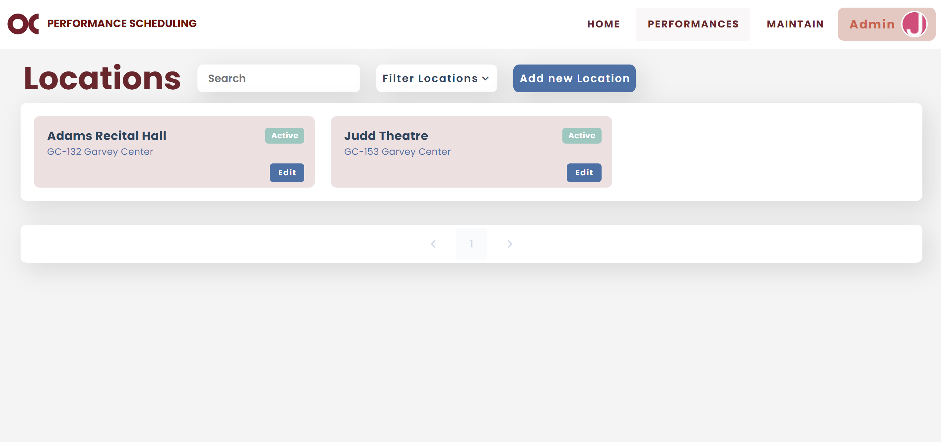

* If you want to edit location information, click on “Edit”.



* If you want to disable a location, you can find it and click “Edit”. Go to the bottom of the pop up and click “Disable”.

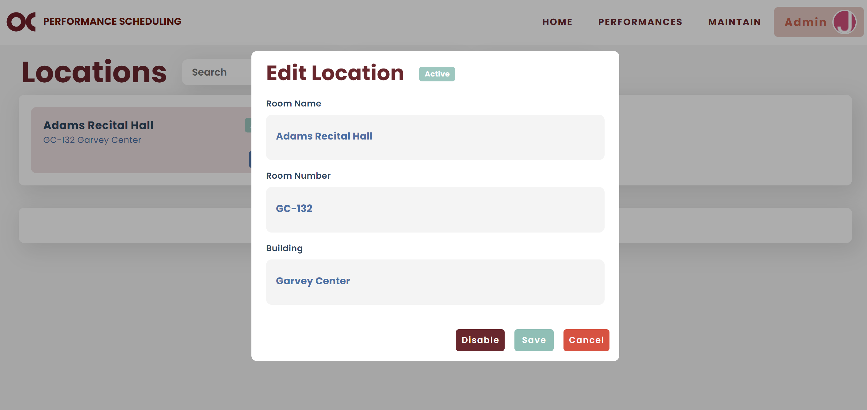

* **Note:** Disabling a location means it cannot be selected for future picks unless they are re-enabled. Its information is not deleted and remains preserved in the system.

## Logout

* Click on Admin and then Logout.

